J QUERY

Note: way of selecting a particular attributes with its value : by using square bracket []

$(document).ready(*function*(){

            $('[data-toggle="tooltip"]').tooltip();

        })

Increase already applied CSS property :

Note : if I have orginal width of 100px but in other function if I want to increase the width by 50px I can do that by the : width : “+=50px “ ;

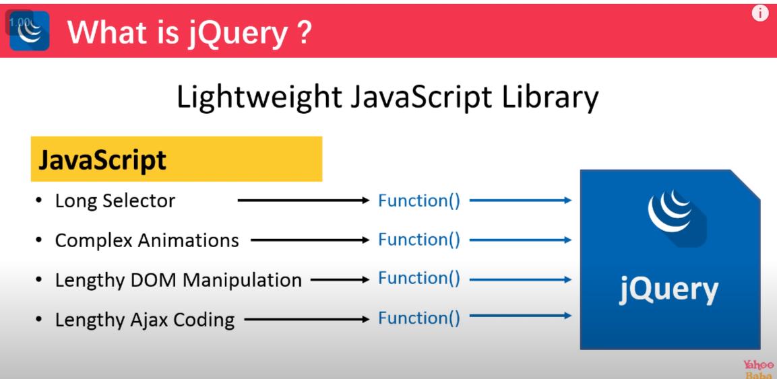

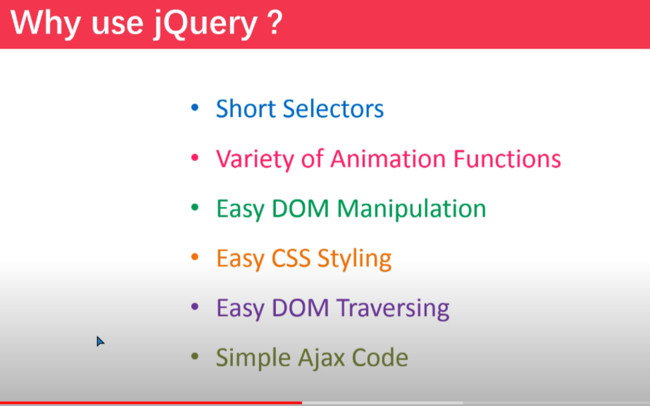

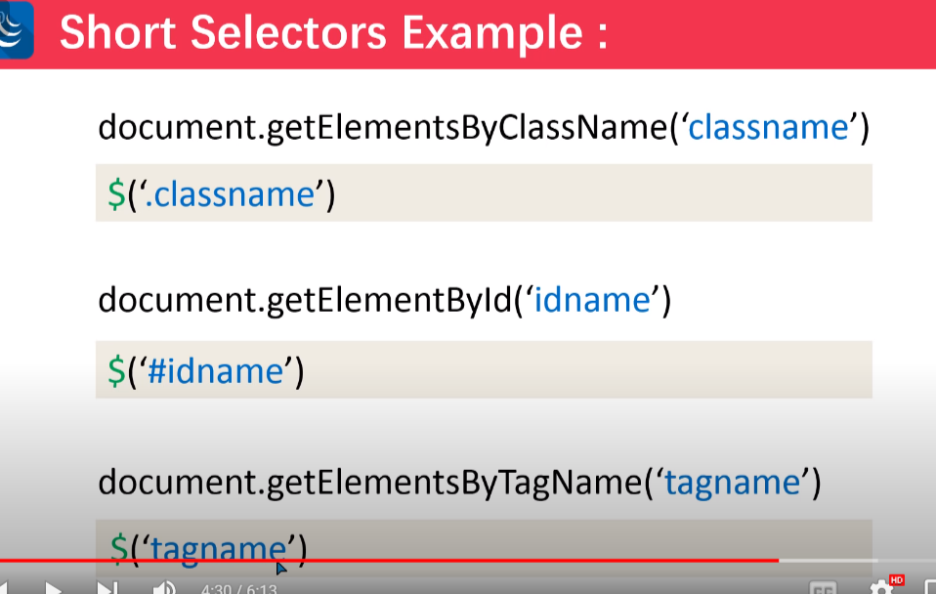

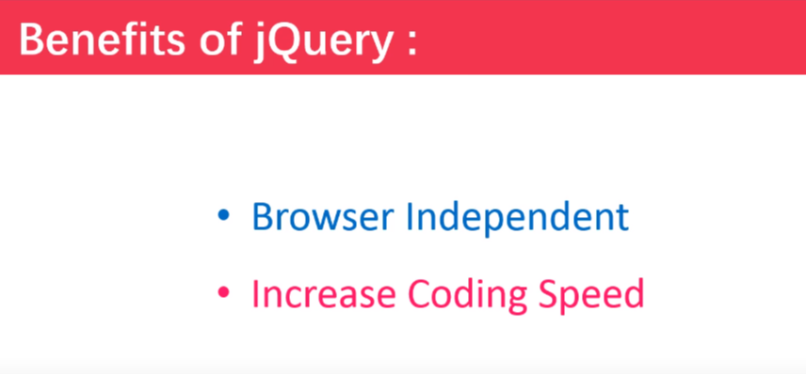

🡺 Adding jQuery in html :

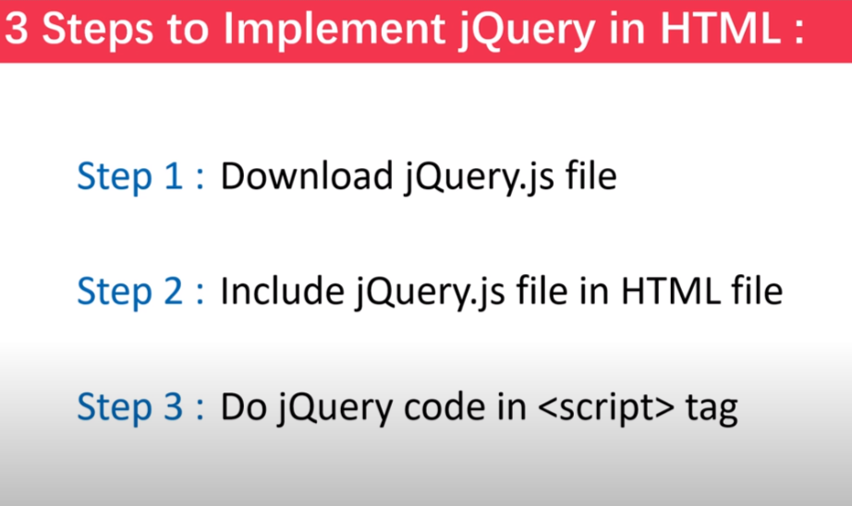

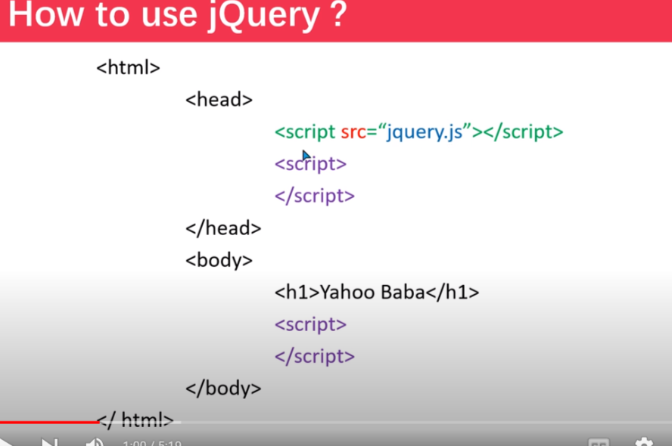

Adding jquery with the cdn :

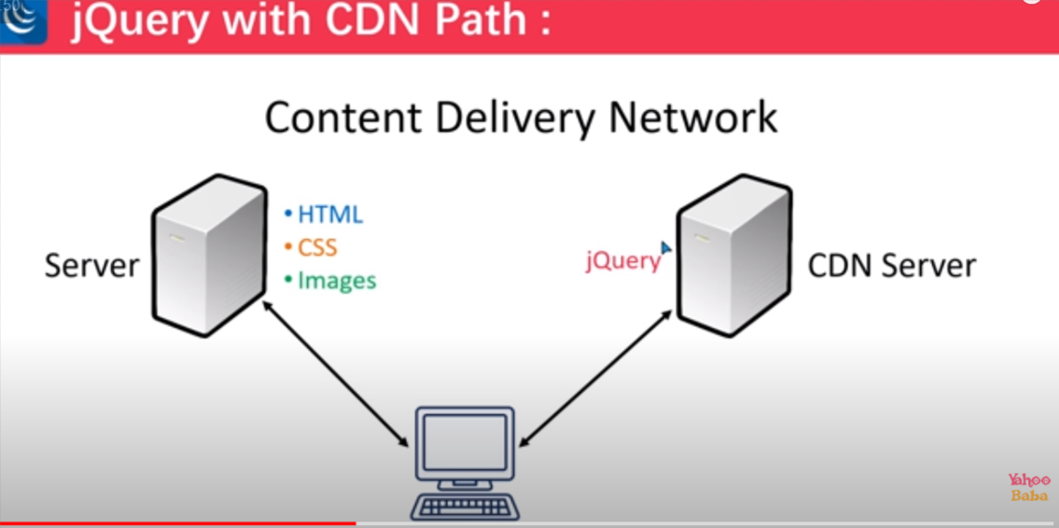

Jquery syntax :

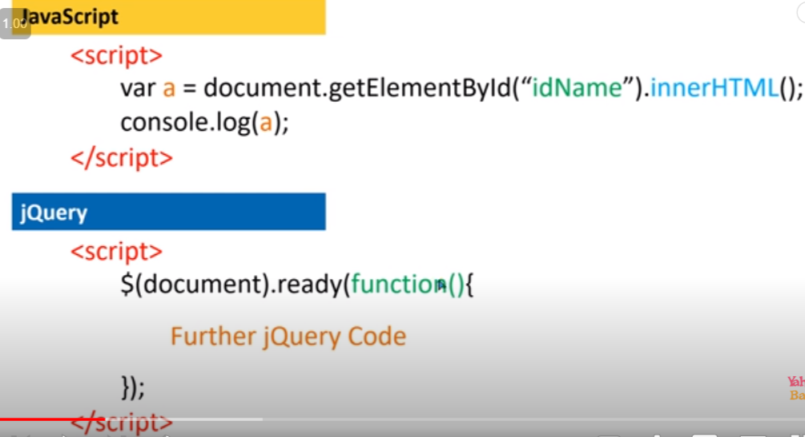

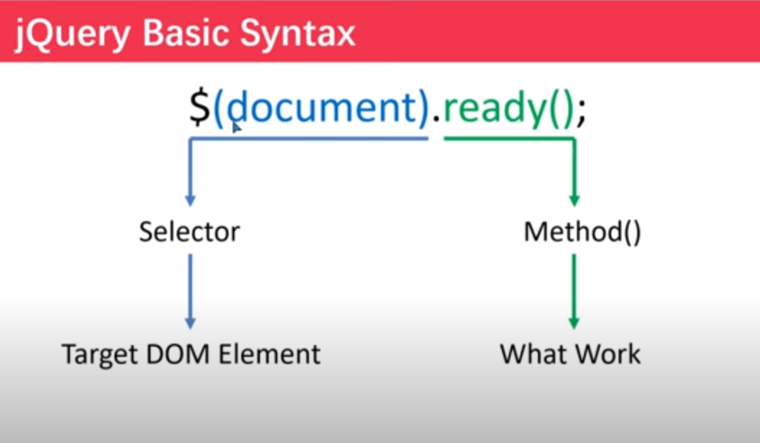

Short syntax :

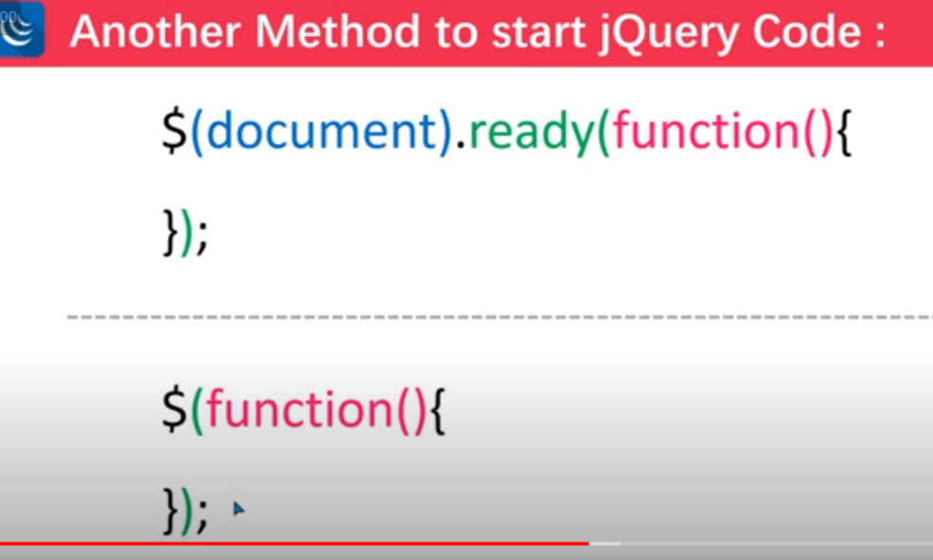

🡺 J Query slector :

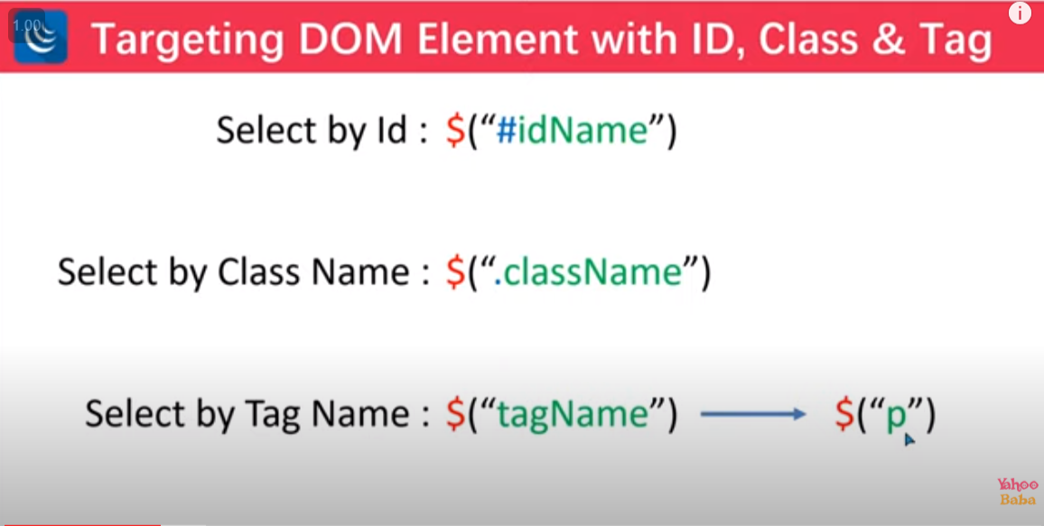

Advance selector :

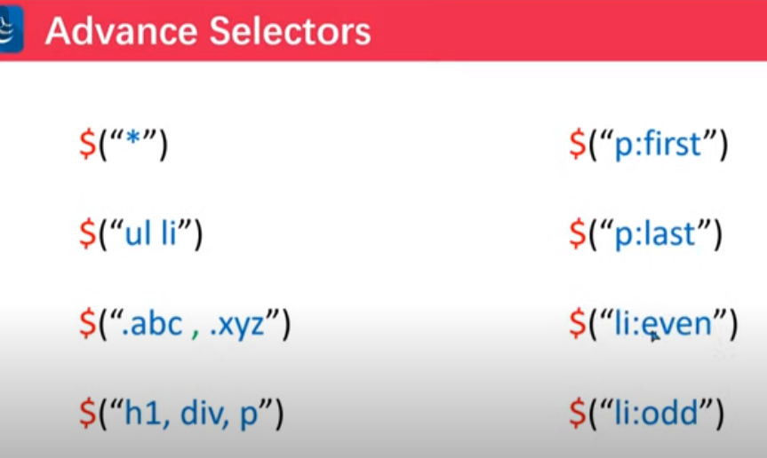

targeting by equation : eq(n);

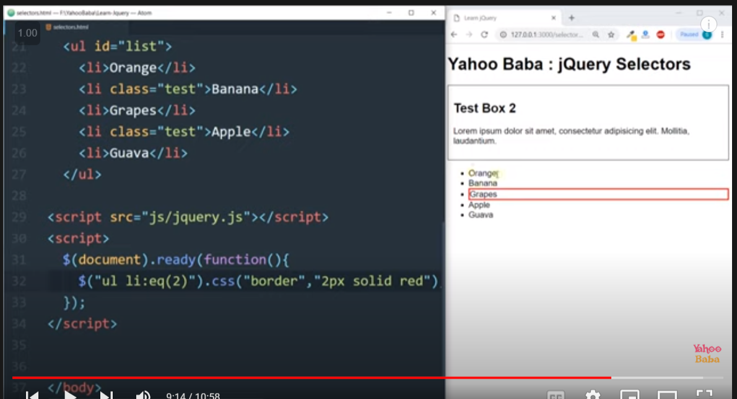

Note : here in equ() indexing start from 0;

🡺 first-child or last-child slector :

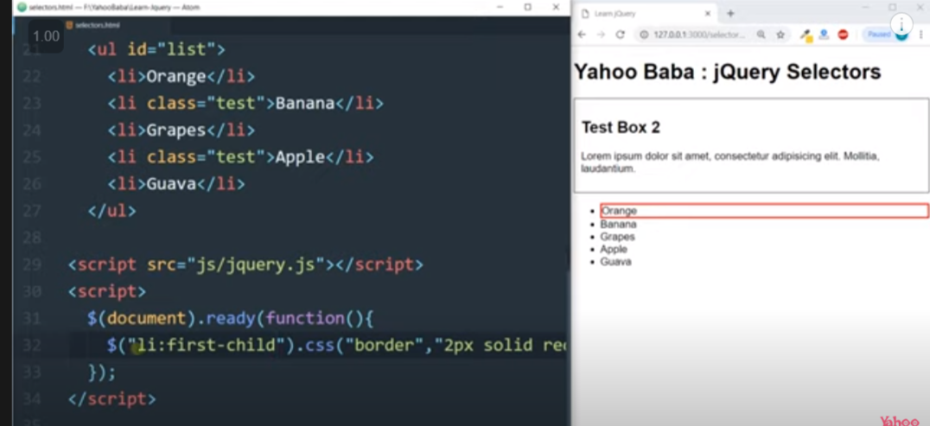

Selection by greater than : gt(n) :

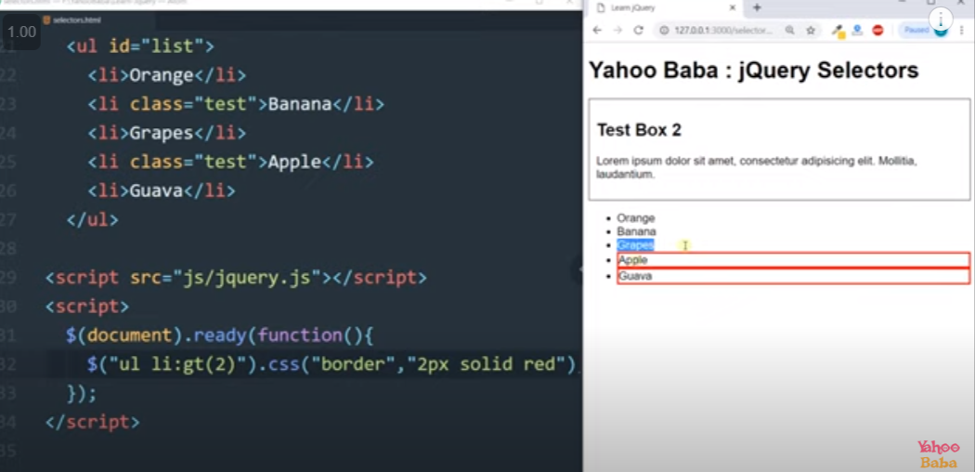

Selection by lower than : lt(n) :

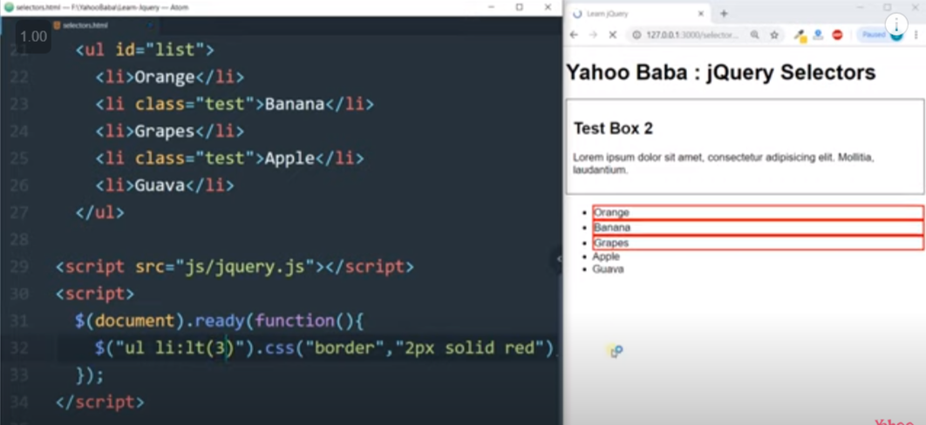

* Selector : nt-child () :

🡺 MOUSE EVENT :

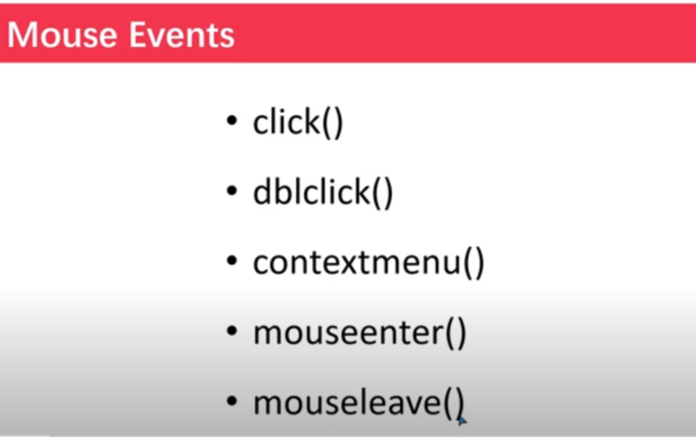

1.Click : one time click

2.dblclick:two time click

3.contextmenu right click

4.mouseenter : means on mouse over

5.mouseleave : means mouse out

<!DOCTYPE html>

<html lang="en">

<head>

    <meta charset="UTF-8">

    <meta http-equiv="X-UA-Compatible" content="IE=edge">

    <meta name="viewport" content="width=device-width, initial-scale=1.0">

    <title>Document</title>

    <style>

        html{

*font-size*: 62.5%;

        }

        #box1{

*border*: 2px black solid;

*padding*: 2rem 2rem;

*font-size*: 1.5rem;

*margin*:0 3vw;

        }

    </style>

    <script src="https://code.jquery.com/jquery-3.6.0.min.js" integrity="sha256-/xUj+3OJU5yExlq6GSYGSHk7tPXikynS7ogEvDej/m4=" crossorigin="anonymous"></script>

</head>

<body>

    <div id="box1">

        <h1>Text box</h1>

        <p>Lorem ipsum dolor sit, amet consectetur adipisicing elit. Corporis provident, similique, expedita eos doloribus aperiam hic incidunt sit cum impedit optio veniam quos tempora. Tempora?</p>

    </div>

    <script>

        $(document).ready(*function*(){

            $('#box1').click(*function*(){

                $("#box1").css("background-color","#27ae60");

            });

            $('#box1').dblclick(()*=>*{

                $('#box1').css("background-color","#e74c3c");

            })

            $('#box1').contextmenu(*function*(){

                $('#box1').css("background-color","#8e44ad");

            })

            $('#box1').mouseenter(*function*(){

                $('#box1').css('background-color',"#1abc9c");

            })

            $('#box1').mouseleave(*function*(){

                $('#box1').css('background-color',"#f1c40f");

            })

        })

    </script>

</body>

</html>

🡺USE OF THIS :

Note : when ever we have to apply any property on the selected dom element which is already selected for that we can use this keywords eg:

$('#box1').mouseleave(*function*(){

                $(this).css('background-color',"#f1c40f");

            })

🡺KEYBOARD EVENT :

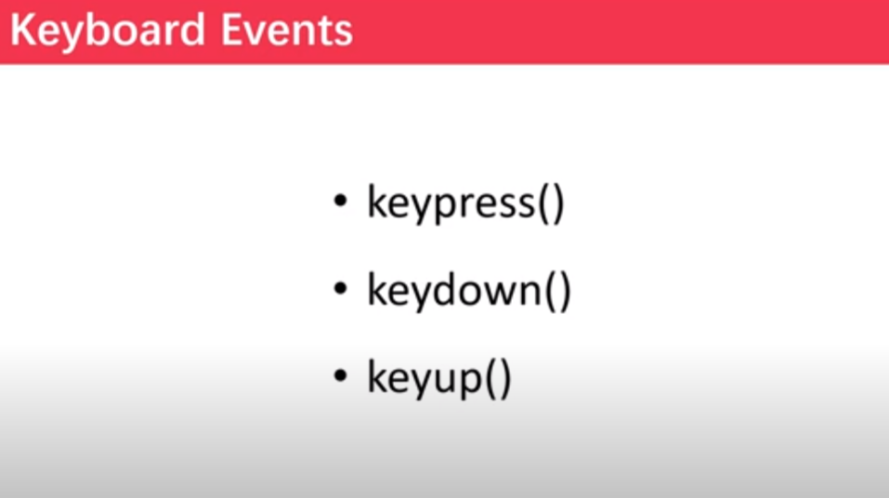

Key up means : jab bhi hum key ko press kar ke chodenge to we envent apply karenga .

<!DOCTYPE html>

<html lang="en">

<head>

    <meta charset="UTF-8">

    <meta http-equiv="X-UA-Compatible" content="IE=edge">

    <meta name="viewport" content="width=device-width, initial-scale=1.0">

    <title>Document</title>

    <style>

        html{

*font-size*: 62.5%;

        }

        #box1{

*border*: 2px black solid;

*padding*: 2rem 2rem;

*font-size*: 1.5rem;

*margin*:0 3vw;

        }

    </style>

    <script src="https://code.jquery.com/jquery-3.6.0.min.js" integrity="sha256-/xUj+3OJU5yExlq6GSYGSHk7tPXikynS7ogEvDej/m4=" crossorigin="anonymous"></script>

</head>

<body>

    <div id="box1">

        <h1>Text box</h1>

        <p>Lorem ipsum dolor sit, amet consectetur adipisicing elit. Corporis provident, similique, expedita eos doloribus aperiam hic incidunt sit cum impedit optio veniam quos tempora. Tempora?</p>

    </div>

    <script>

        $(document).ready(*function*(){

            $('body').keypress(*function*(){

                $(this).css("background-color","green");

            });

            $('body').keydown(*function*(){

                $(this).css("background-color","#e74c3c");

            })

            $('body').keyup(*function*(){

                $(this).css("background-color","#2980b9");

            })

        })

    </script>

</body>

</html>

Note : way of selelcting multiple element :

 $(document).ready(*function*(){

            $('#myname,#myclass,#id,#myselect,#submit').focus(*function*(){

                $(this).css("background-color","#8e44ad");

            })

        })

Form Event :

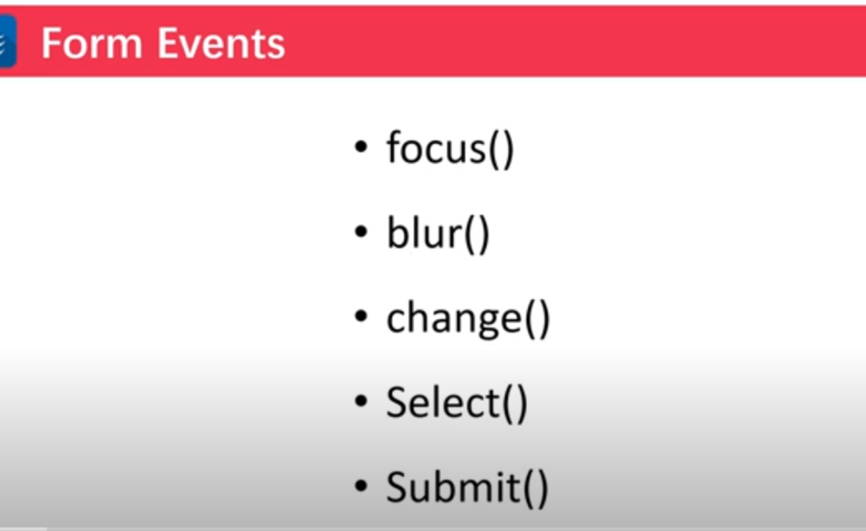

1.foucs : when ever we select the field then the foucus event will called .

2.blur : when ever any filed of the form is not selected then this property will be applied .

3.change : this genrally applied on the select form filed .

4.submit : this applied on the form id and it will applied when we click on the submit button .

5.select : when ever we select the content in the form field then this event will be going to called .

<!DOCTYPE html>

<html lang="en">

<head>

    <meta charset="UTF-8">

    <meta http-equiv="X-UA-Compatible" content="IE=edge">

    <meta name="viewport" content="width=device-width, initial-scale=1.0">

    <title>Document</title>

    <script src="https://code.jquery.com/jquery-3.6.0.min.js" integrity="sha256-/xUj+3OJU5yExlq6GSYGSHk7tPXikynS7ogEvDej/m4=" crossorigin="anonymous"></script>

</head>

<body>

    <form action="" id="myform">

        Name : <input type="text" id="myname"><br><br>

        class : <input type="text" id="myclass"><br><br>

        id : <input type="text" id="id"><br><br>

        country : <select name="" id="myselect">

            <option value="" selected hidden>Select any one country</option>

            <option value="">india</option>

            <option value="">pakistan</option>

            <option value="">Nepal</option>

            <option value="">Srilank</option>

            <option value="">Bangladesh</option>

        </select><br><br>

        <button type="submit" id="submit">submit</button>

    </form>

    <script>

        $(document).ready(*function*(){

            $('#myname,#myclass,#id,#myselect,#submit').focus(*function*(){

                $(this).css("background-color","#8e44ad");

            })

        })

        $(document).ready(*function*(){

            $('#myname,#myclass,#id,#myselect,#submit').blur(*function*(){

                $(this).css("background-color","");

            })

        })

        $(document).ready(*function*(){

            $('#myname,#myclass,#id,#myselect,#submit').select(*function*(){

                $(this).css("background-color","yellow");

            })

        })

        $('#myselect').change(*function*(){

            $(this).css("background-color","orange");

        })

        $('#myform').submit(*function*(){

           alert("file have been sucessfully submitted");

        })

    </script>

</body>

</html>

Windows event :

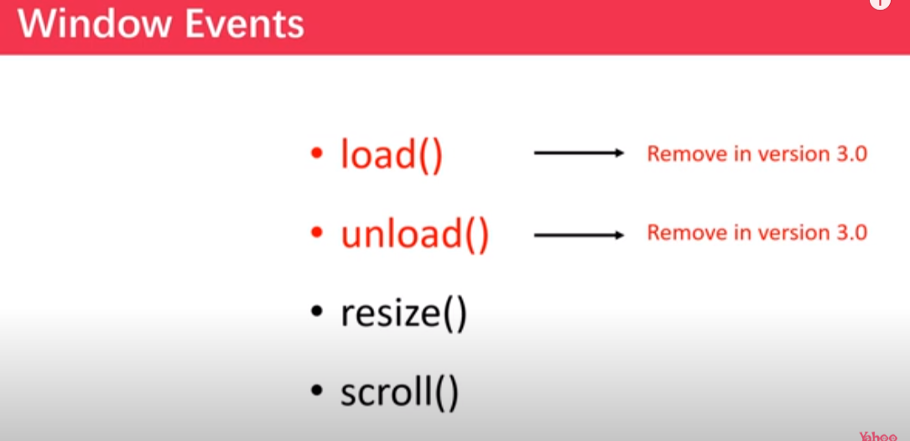

Note :scroll and resize or any other can be use with the other element of DOM instead of window .

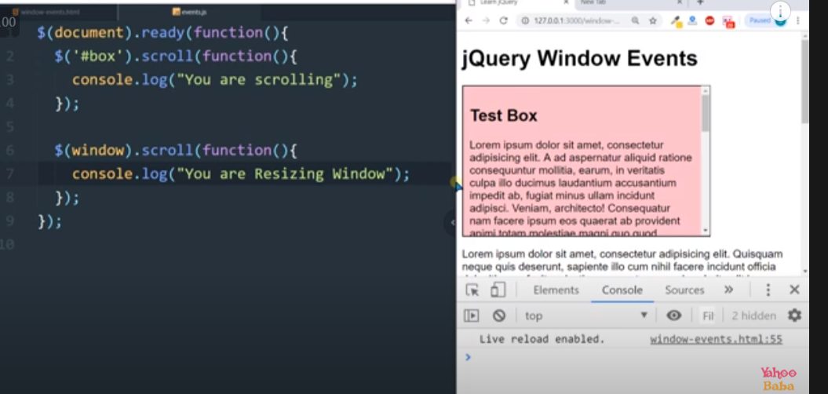

🡺GET METHOD :

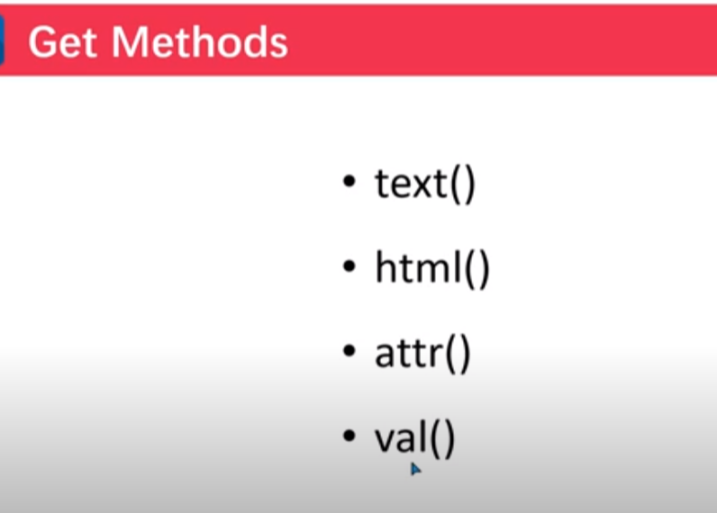

Attr get method :

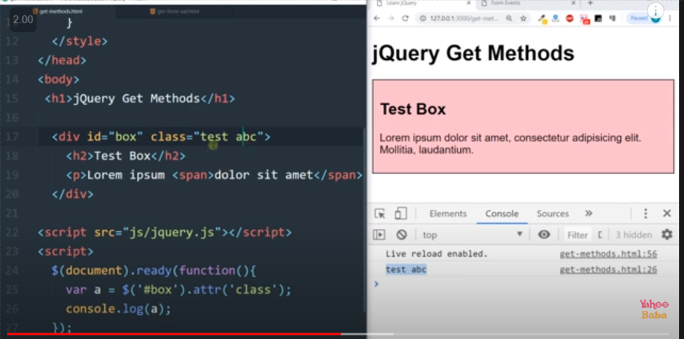

🡺SET METHOD :

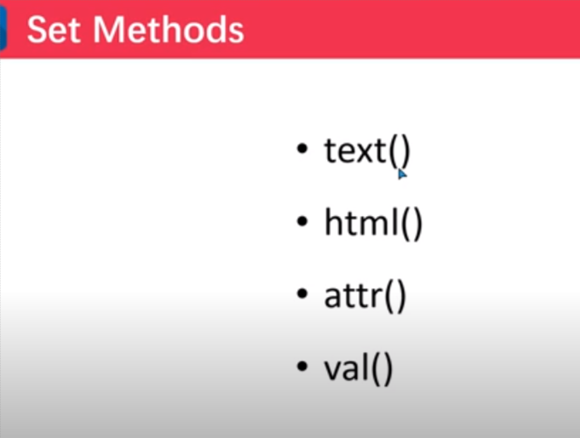

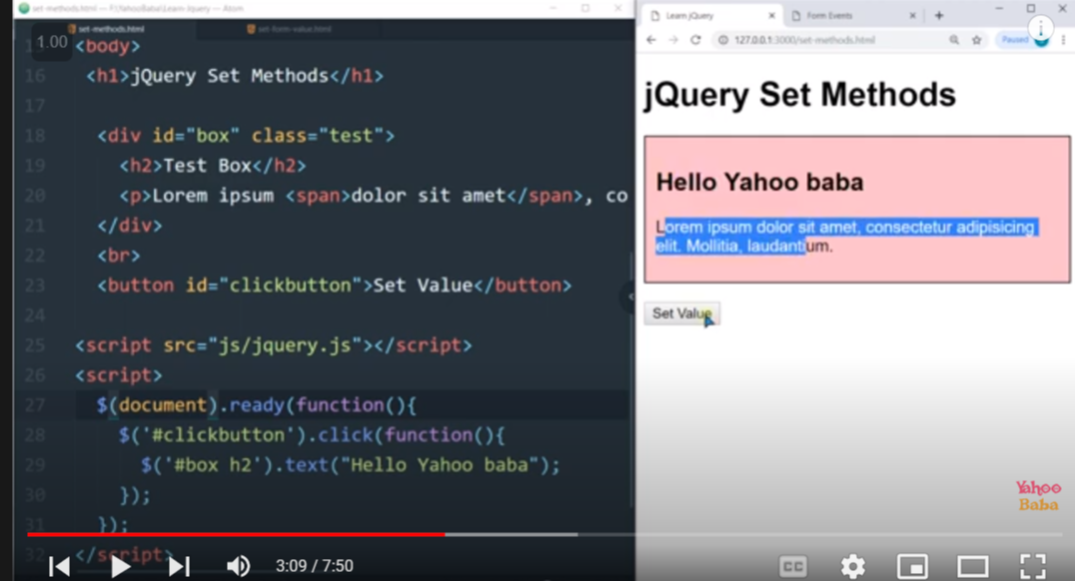

Attributes set :

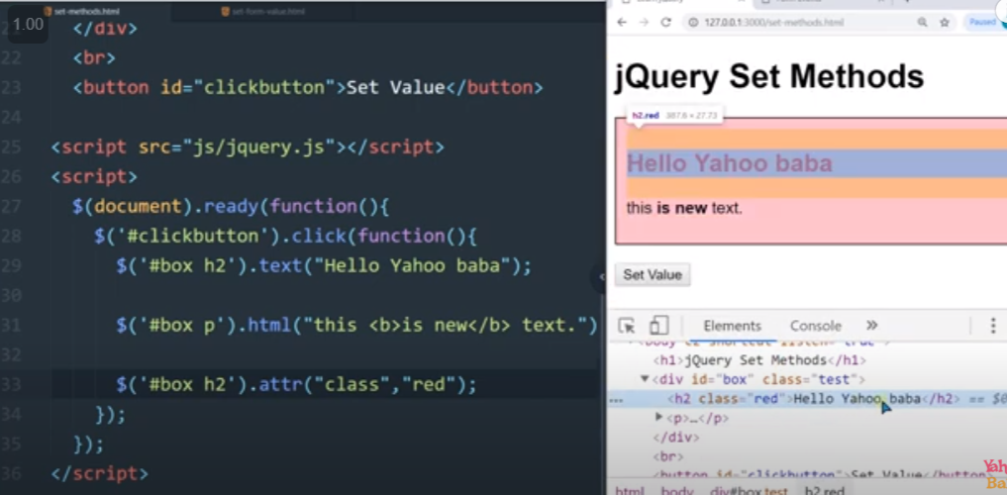

🡺Class list in j query :

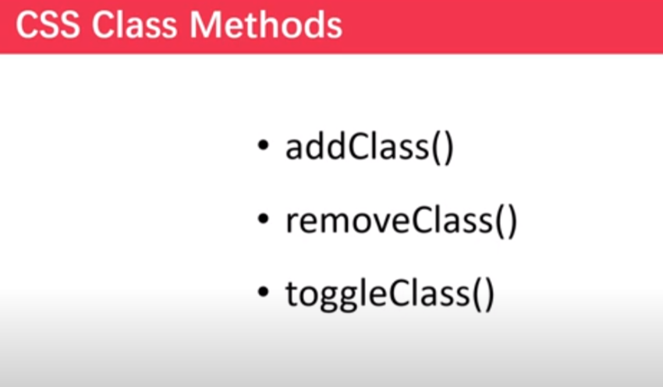

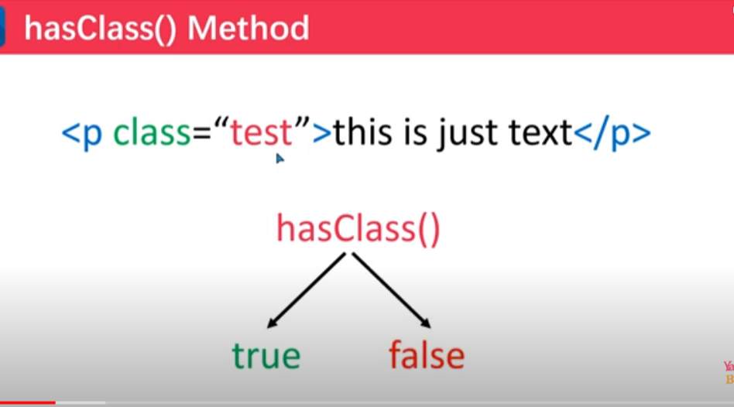

🡺Adding multiple class :

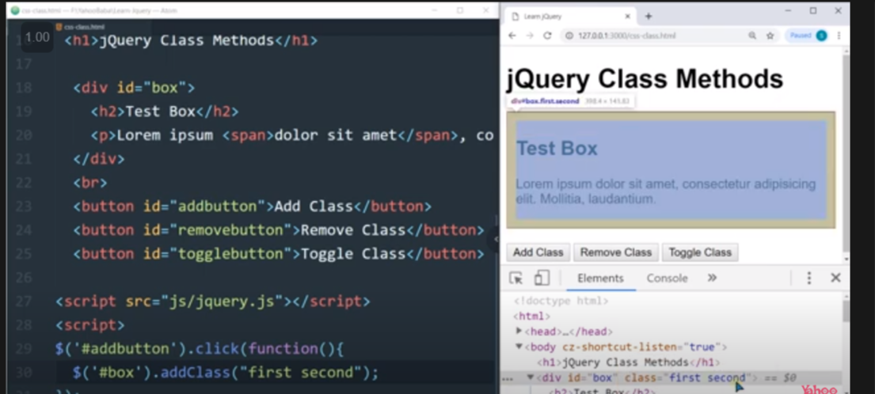

🡺Adding in line css :

We can use css method

🡺Adding multiple inline css property :by using curly bracket .

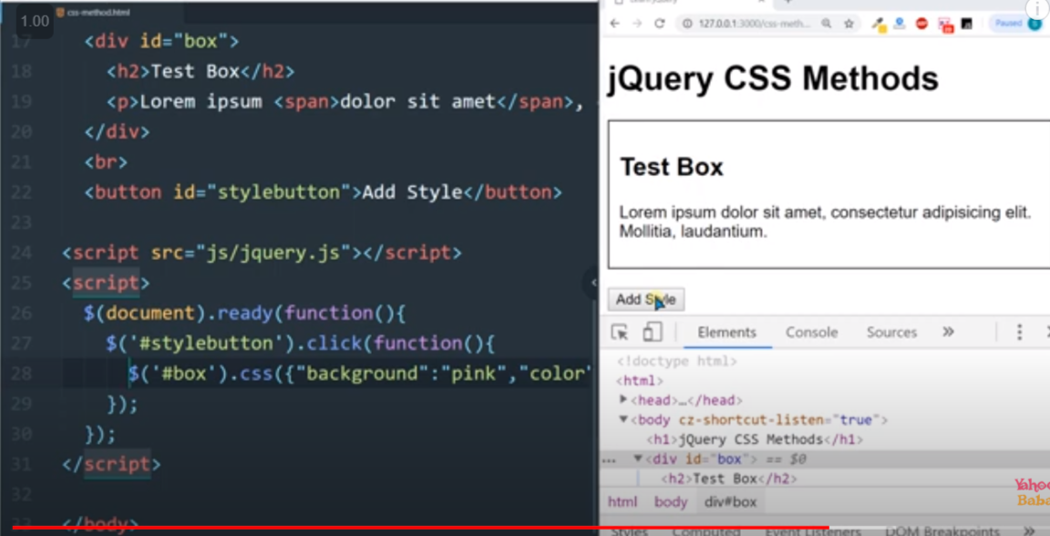

8. on and off :

Previous :

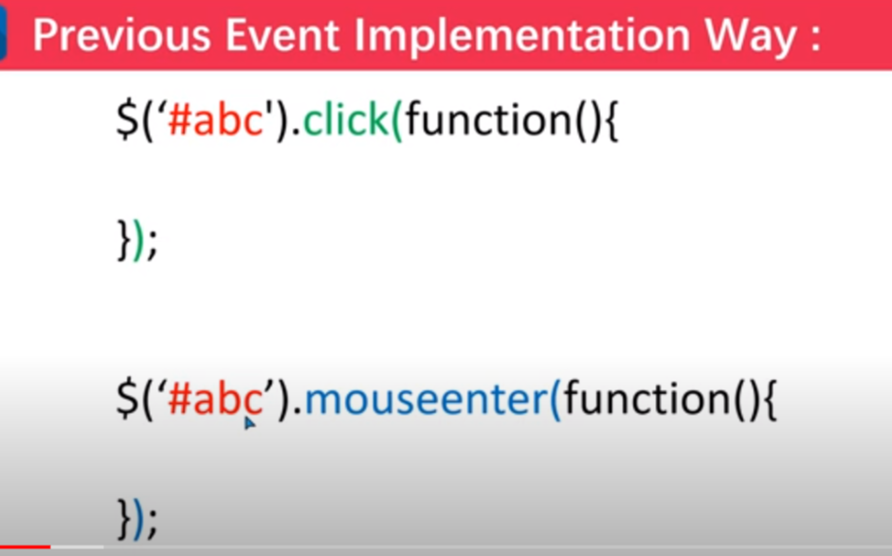

By using on :

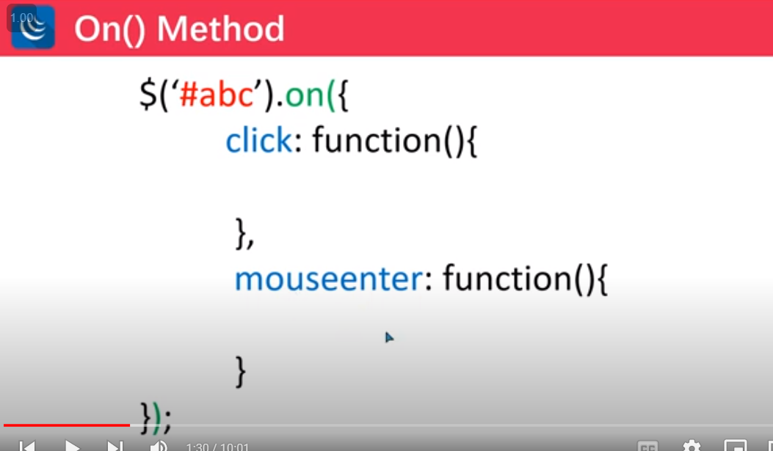

Eg :

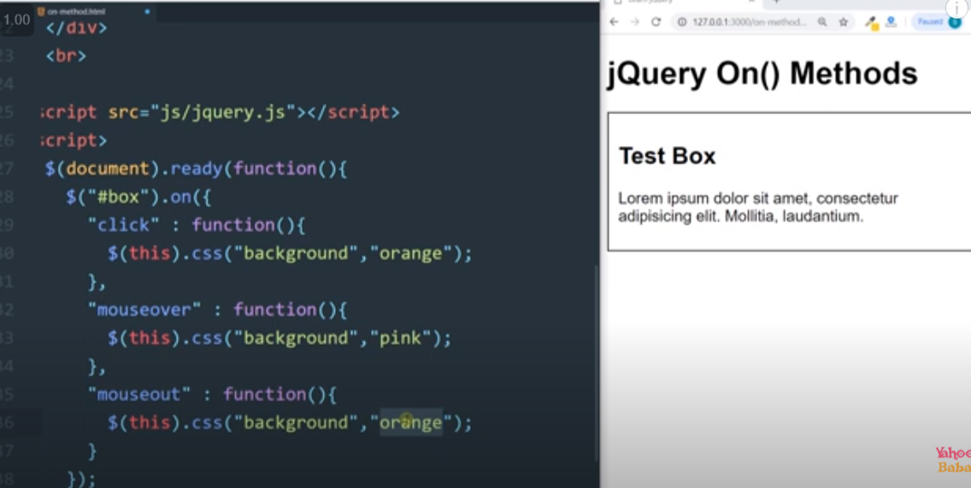

🡺other way of using or using on function for one event or for if I want to add same function for multiple event :

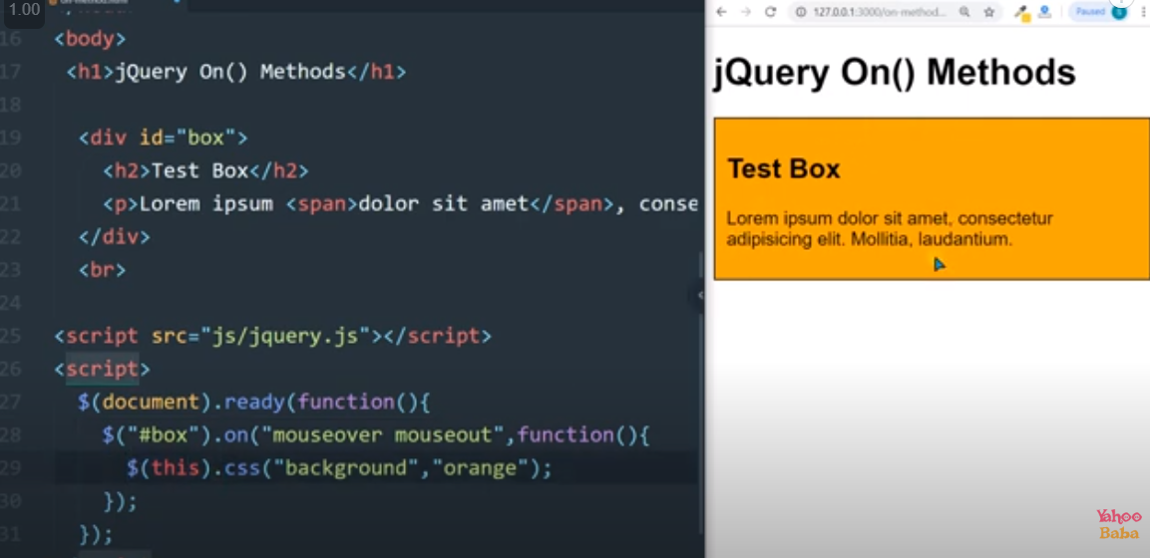

🡺 using of off method: if I want to not use certain event for that purpose I can use off method :

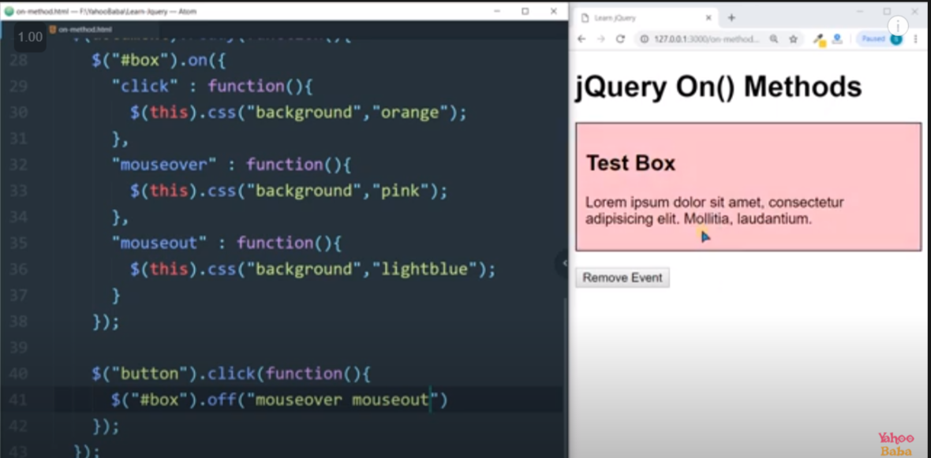

9.

9.1 .Append() or prepend():

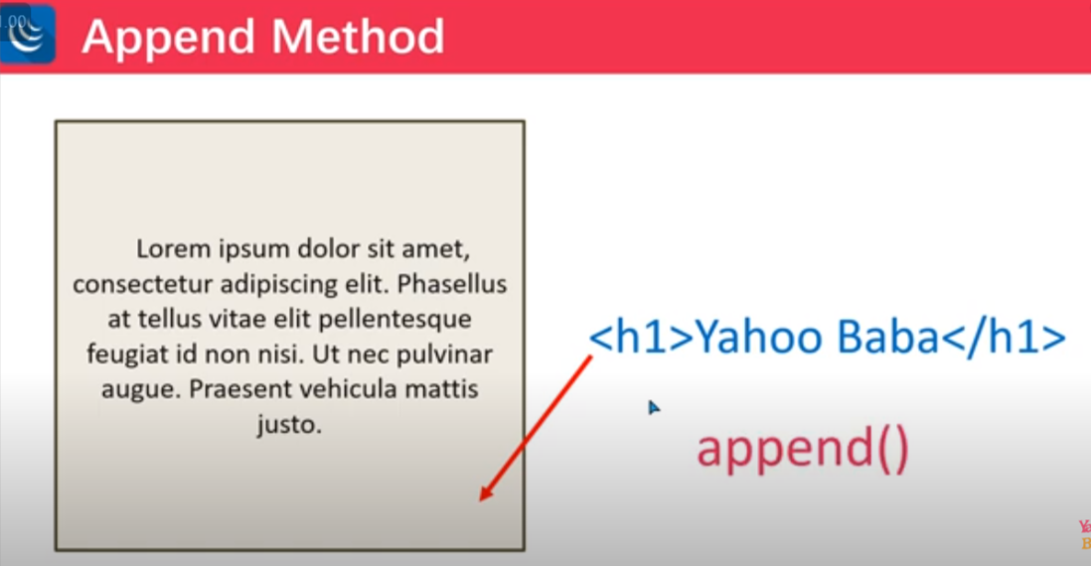

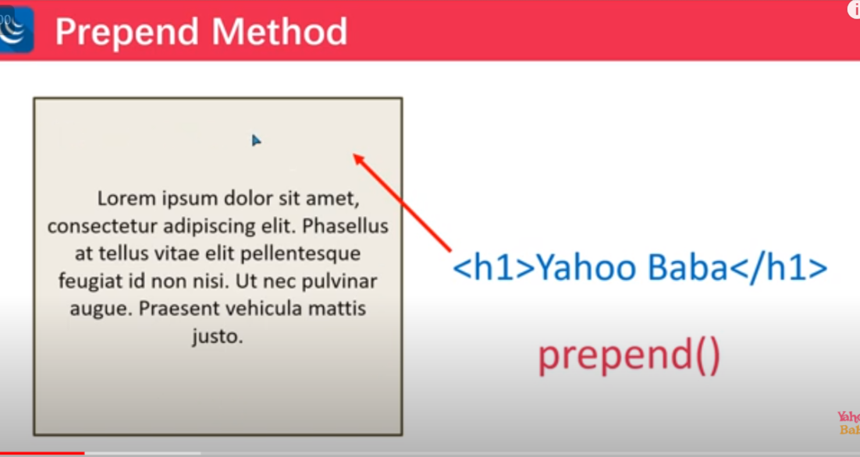

9.2 After and before :

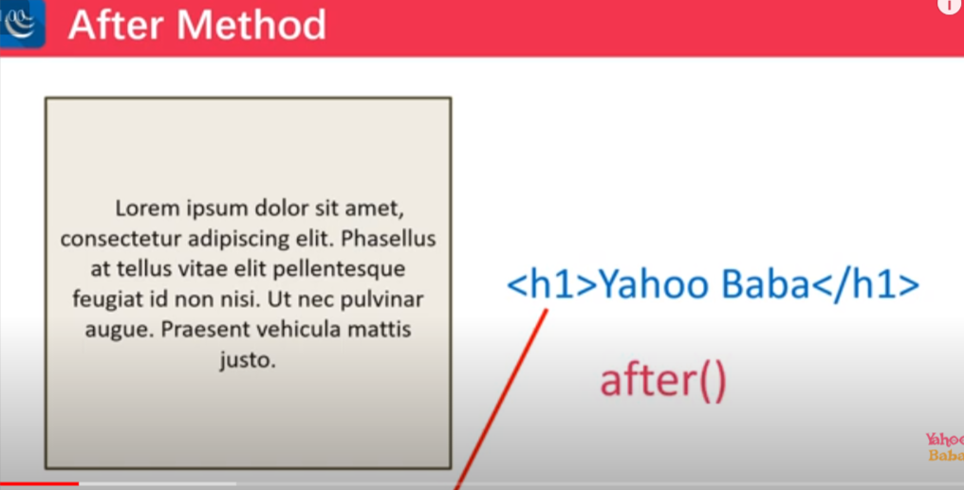

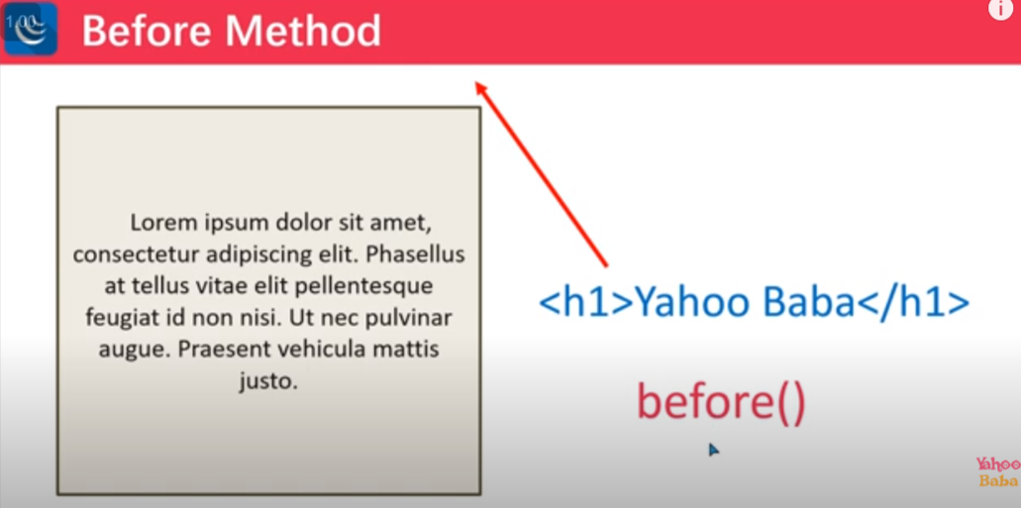

9.3 Empty and remove :

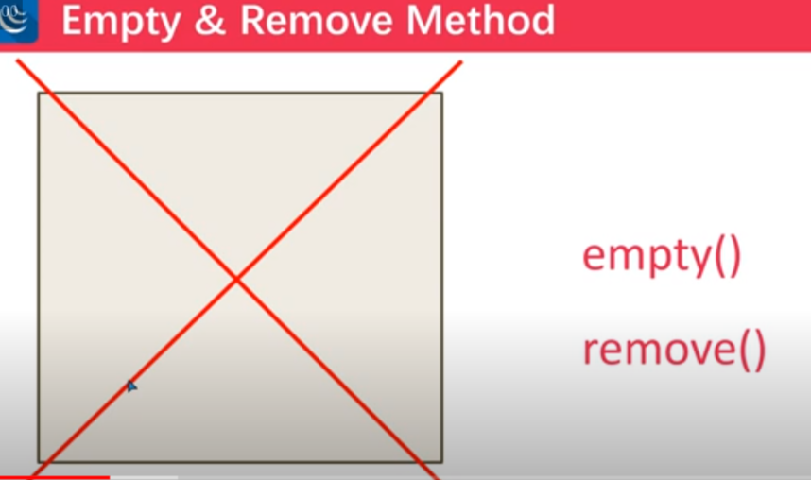

9.4 AppendTo() and prependTo() : both work same as append and prepend but have syntax difference .

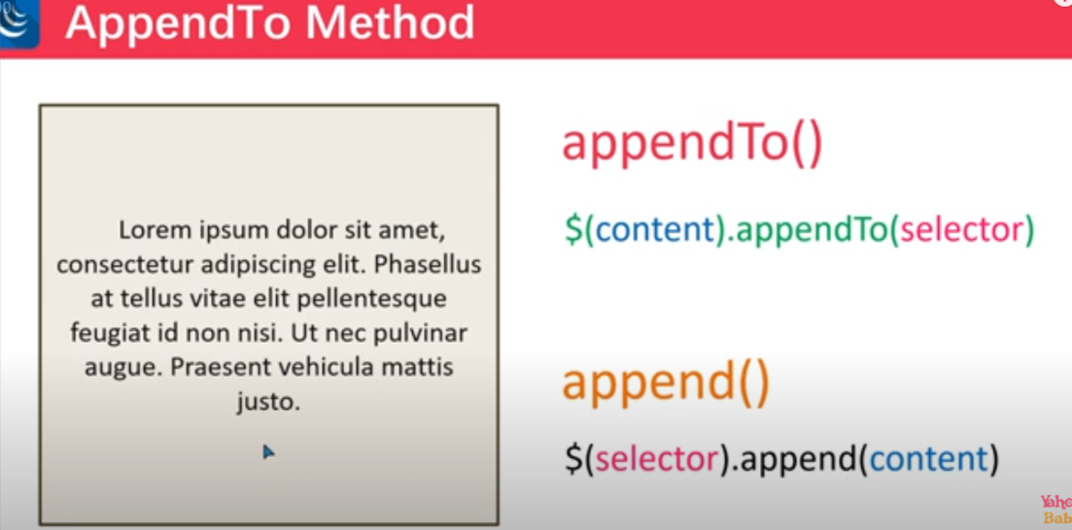

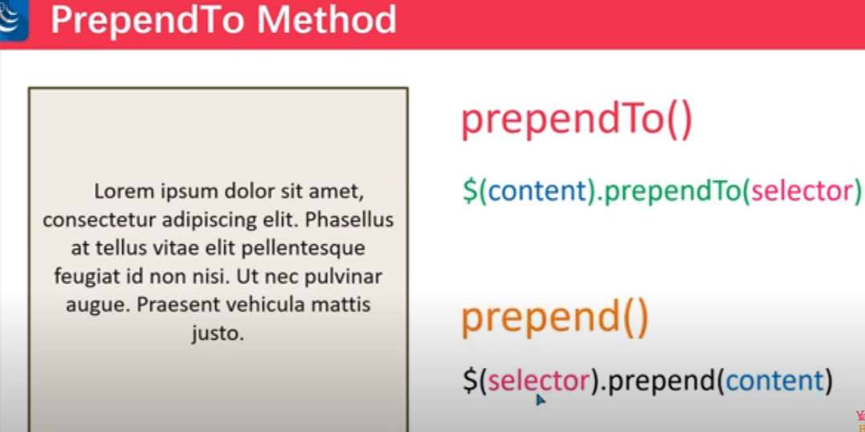

9.5. clone ();

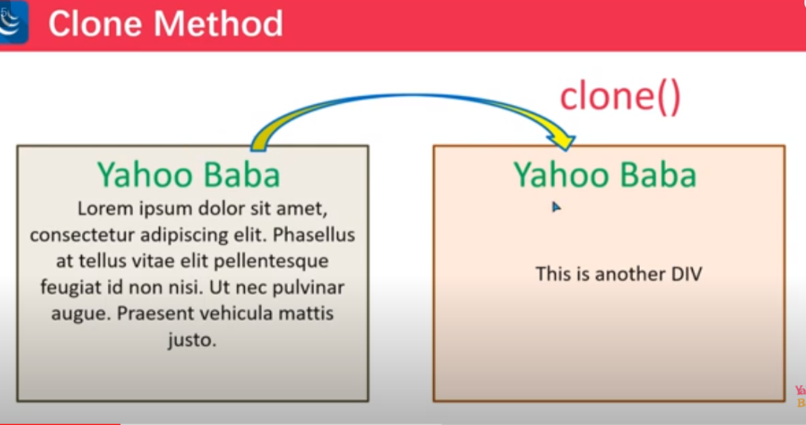

9.6.

ReplaceWith():with the help of replace we replace any particular selector with the given selector .

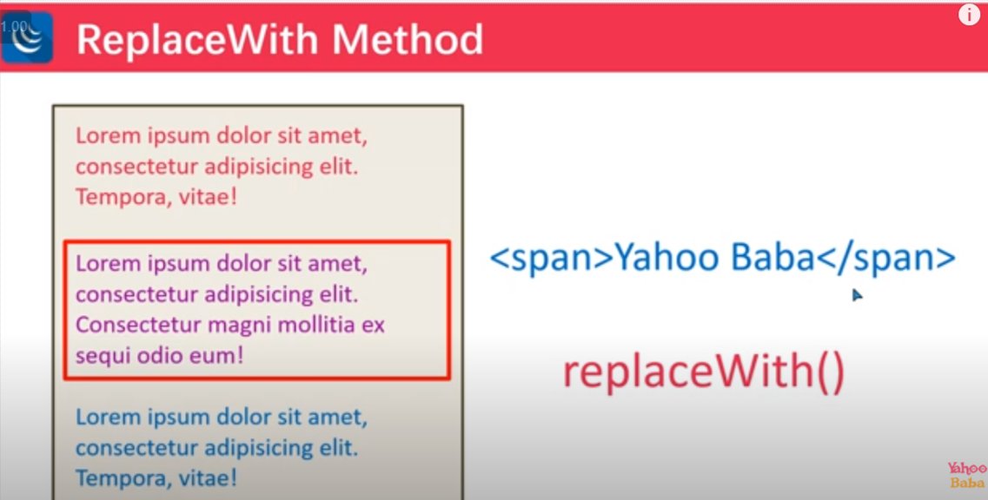

Note : in replace with we can also replace with the text also .

9.7 wrap and unwrap method :

This method is use to add/remove parent tag for selected element .

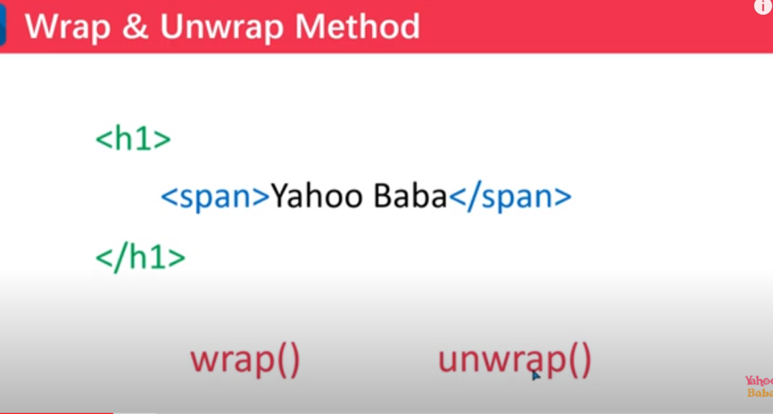

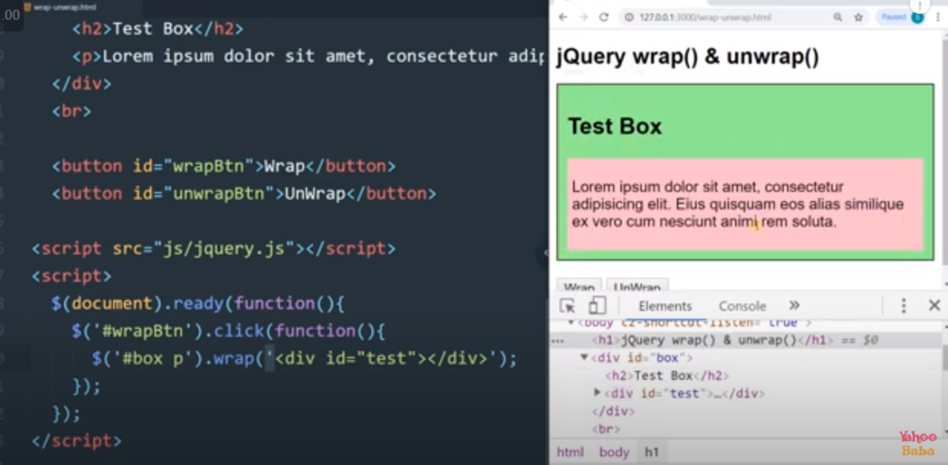

Unwrap : remove the parent

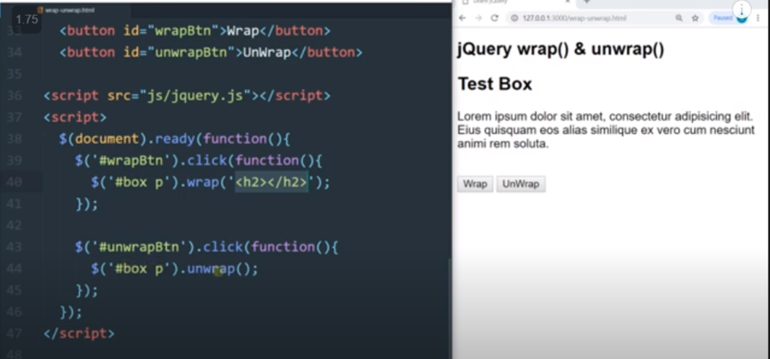

10.width and height :

A)width :

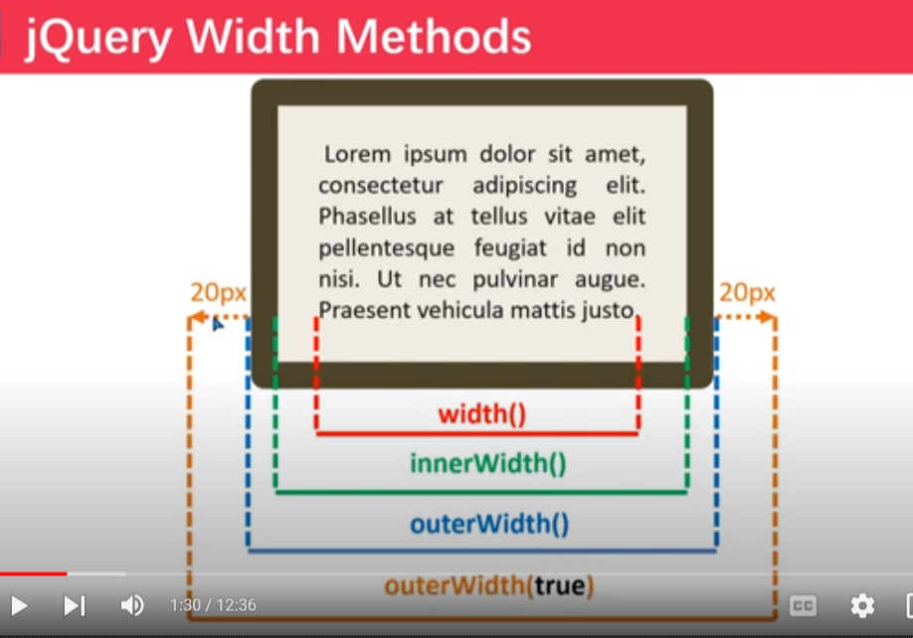

b) height :

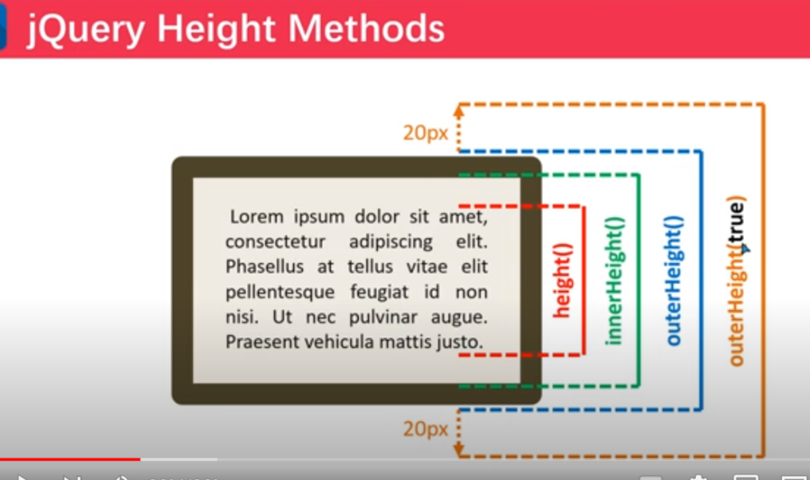

11.Animation

11.1. hide (), show () and toggle () :

a)hide:is used to hide something

b)show : is used to show something .

c)toggle : is used to hide and show something

parameter :

first parameter : “slow”, “fast” ,1000(1sec) ,3000(3sec)

second parameter : call back function .

note : both the parameter is optional .

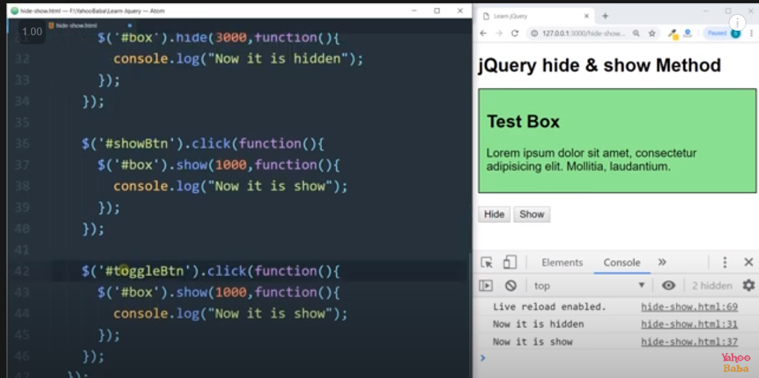

11.2 .

a)fadeout() :used to hide in fading manner

b)fadein() : used to show the hidden content in fading manner .

3)fadetoggle() : it will going to hide and show in fading manner .

Parameter :

parameter :

first parameter : “slow”, “fast” ,1000(1sec) ,3000(3sec)

second parameter : call back function .

note : both the parameter is optional .

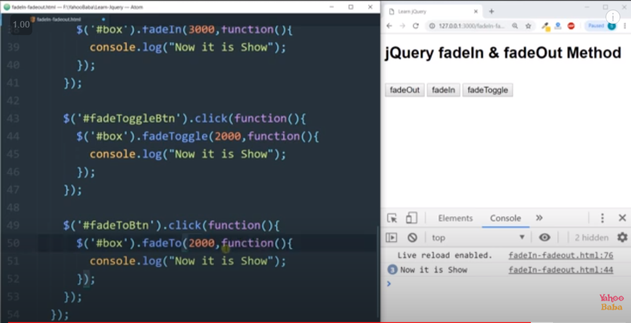

11.3 slideup() , slidedown() and slidetoggle()

Parameter :

first parameter : “slow”, “fast” ,1000(1sec) ,3000(3sec)

second parameter : call back function .

note : both the parameter is optional .

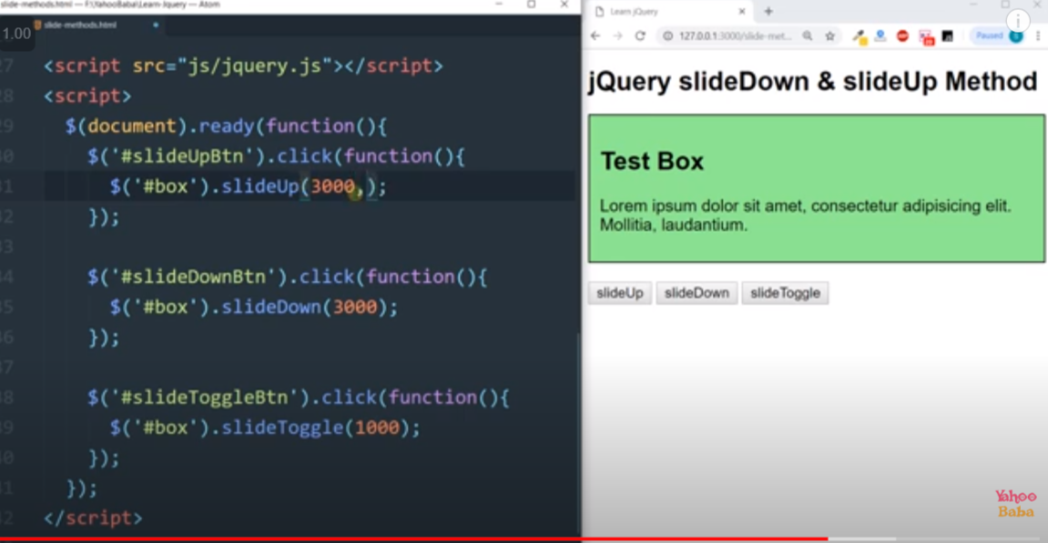

11.4.Animate :

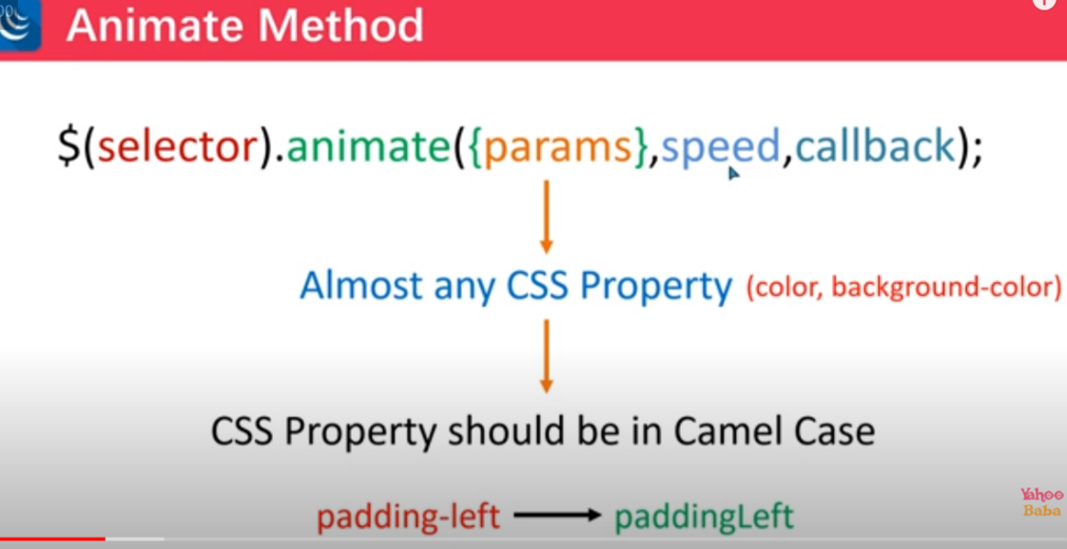

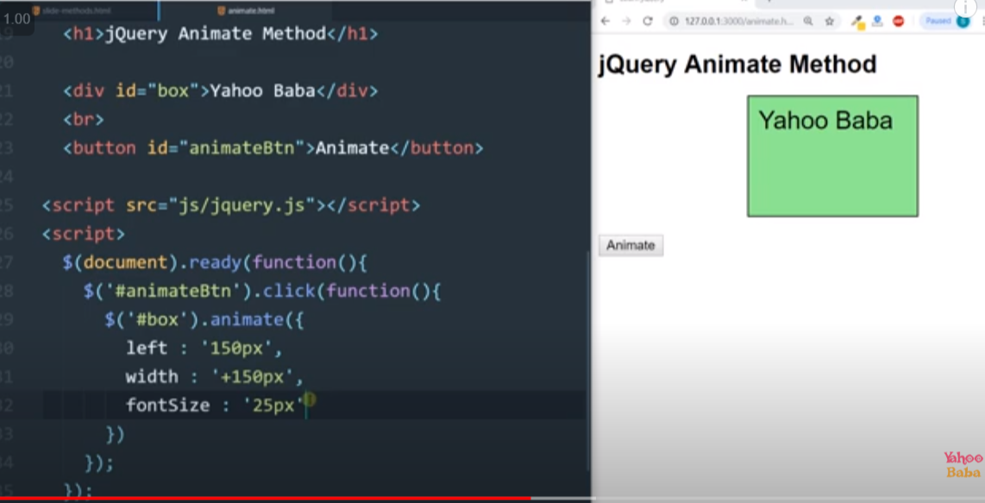

Animation queue: if we want to apply animation in sequence manner.

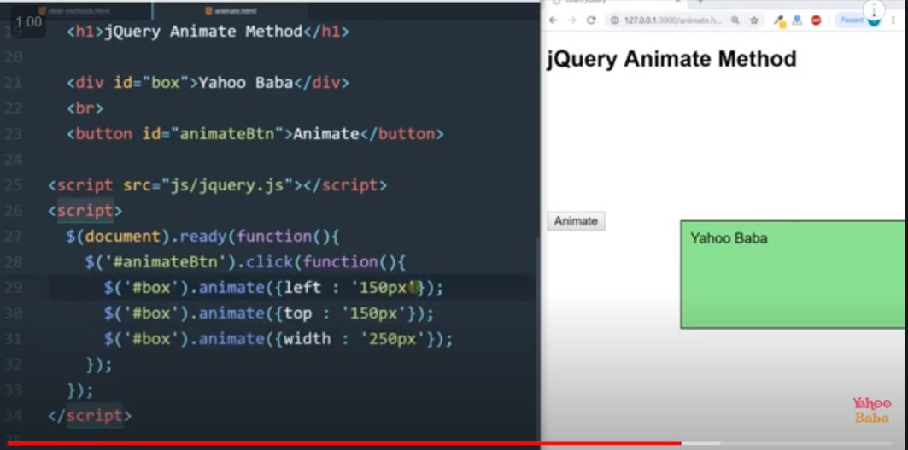

12. stop():

Parameter :

1st parameter : true/false

2nd parameter : true / false

Note : it is applied on all animation that I have write above .

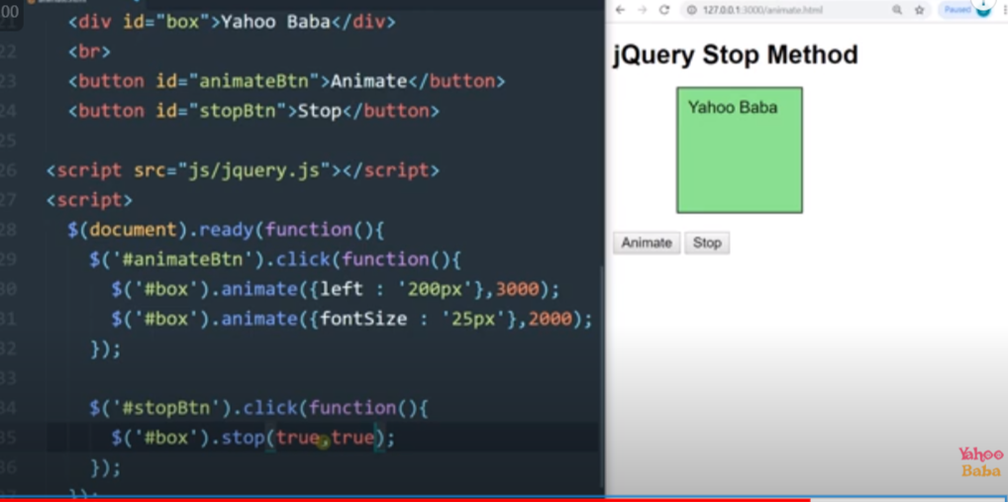

13.medtod chaining :

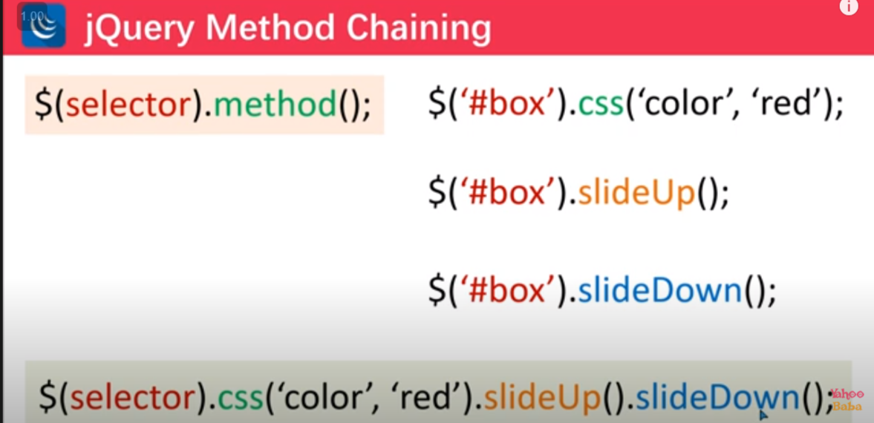

14.DOM TRAVERSAL IN J QUERY :

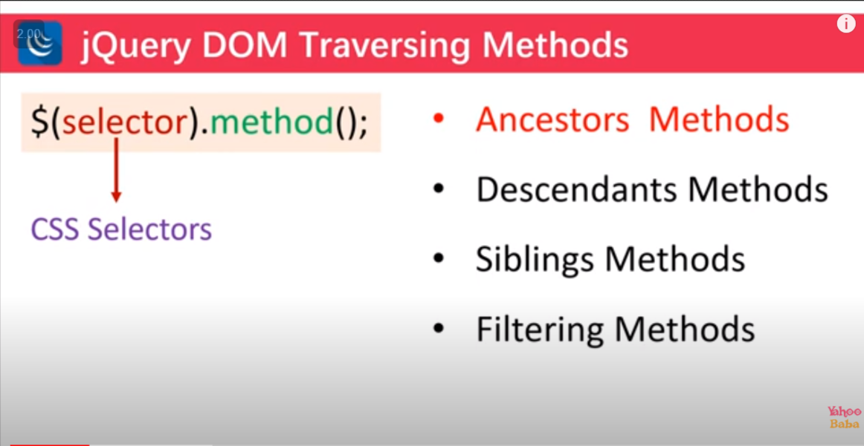

1.Ancestors methods :

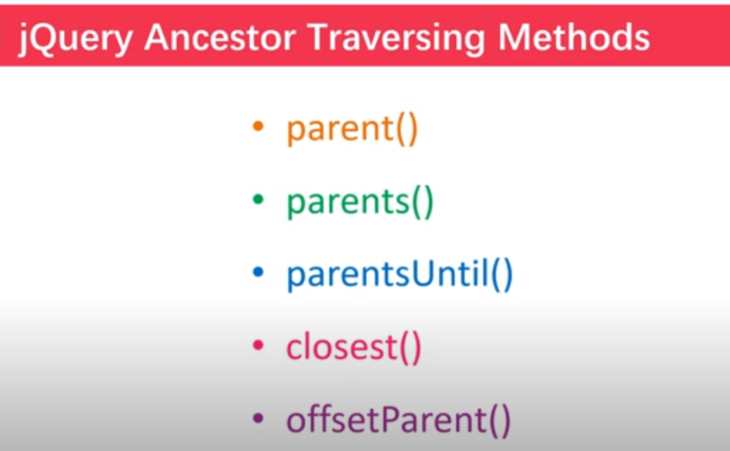

A)parent : it will going to select the imidiate parent

B)parents: it will going to select the all parent .

Note : we can also select the particular parent by passing the parmeter like parent name or id or class .

C)ParentsUntil(): it will going to select the all the parent exculiding the give limit that has been give as parameter .

D)OffsetParent() : it will going to select the first parent that has css position property .

E)collogest() :it will going the select the first element that match with the give parameter .

2.Descendendent method ():

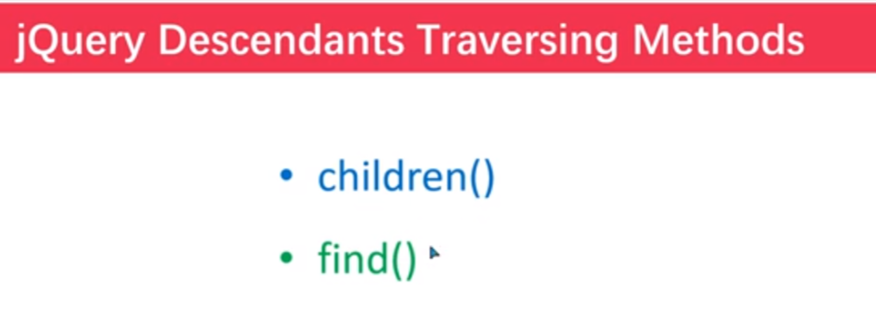

1. Children() : it will going to select all of its children . It will not going to select its grand children .

Note : we can also pass value for particular selection .

1. Find() : it will going to take input and it will going to find that input in its children and also in its grand children and so on .

Difference between find and children :

Children() : children will going to select in its children only it will not going to find in its grand children .

Find() : fined() will going to select from its children and its all grand children .

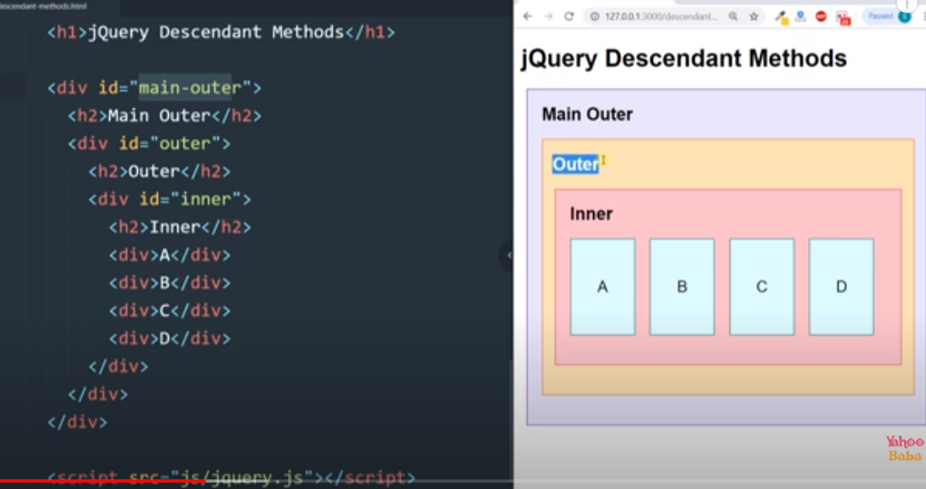

1. Children eg :

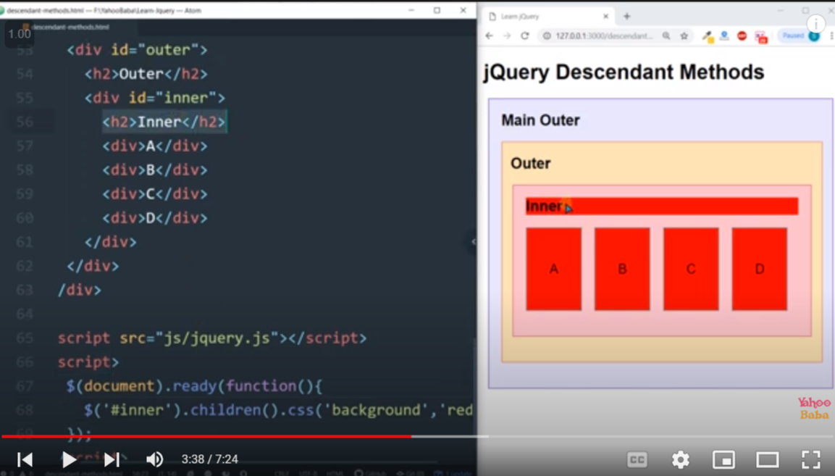

B)find() eg :

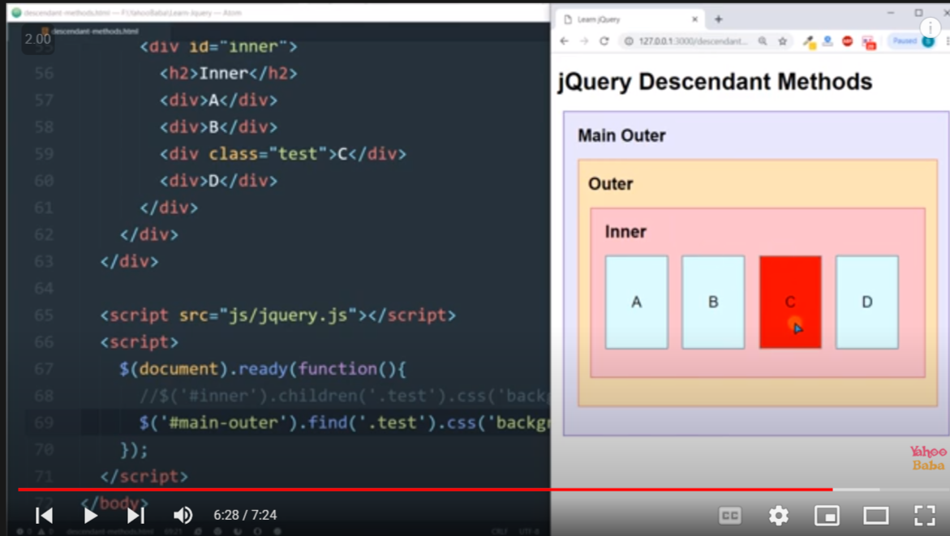

3)Siblings method :

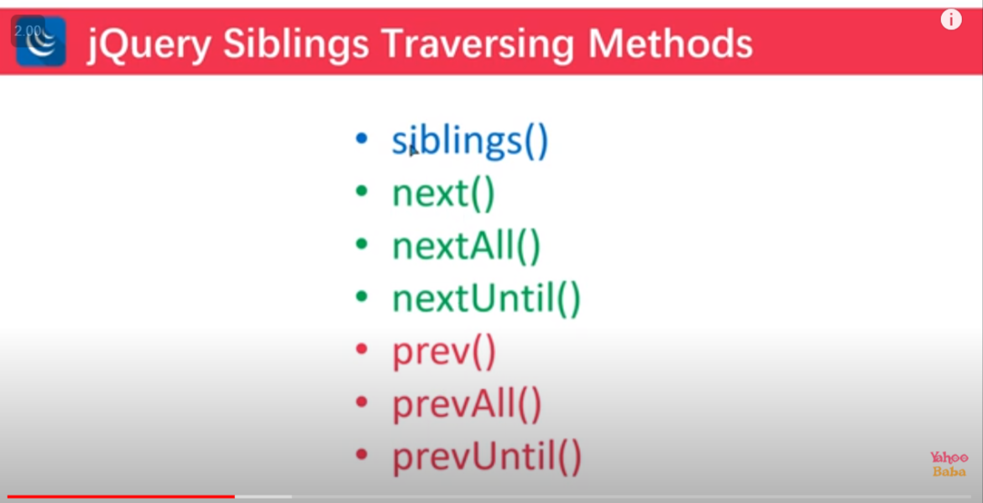

4.filtring method :

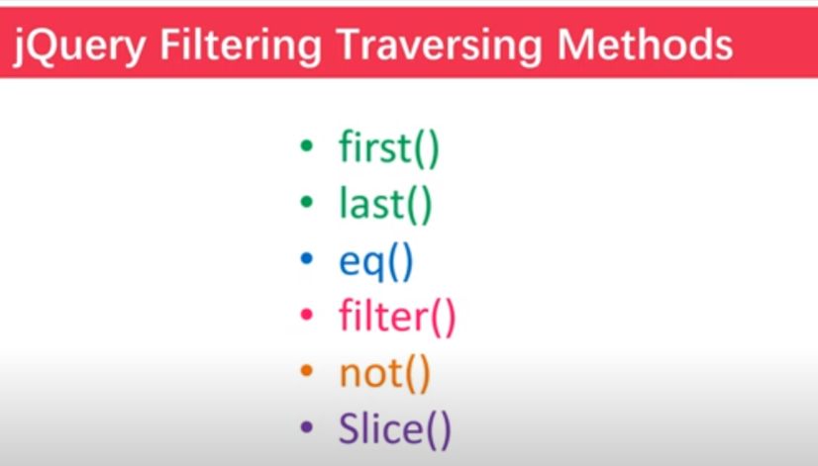

Filter () eg :

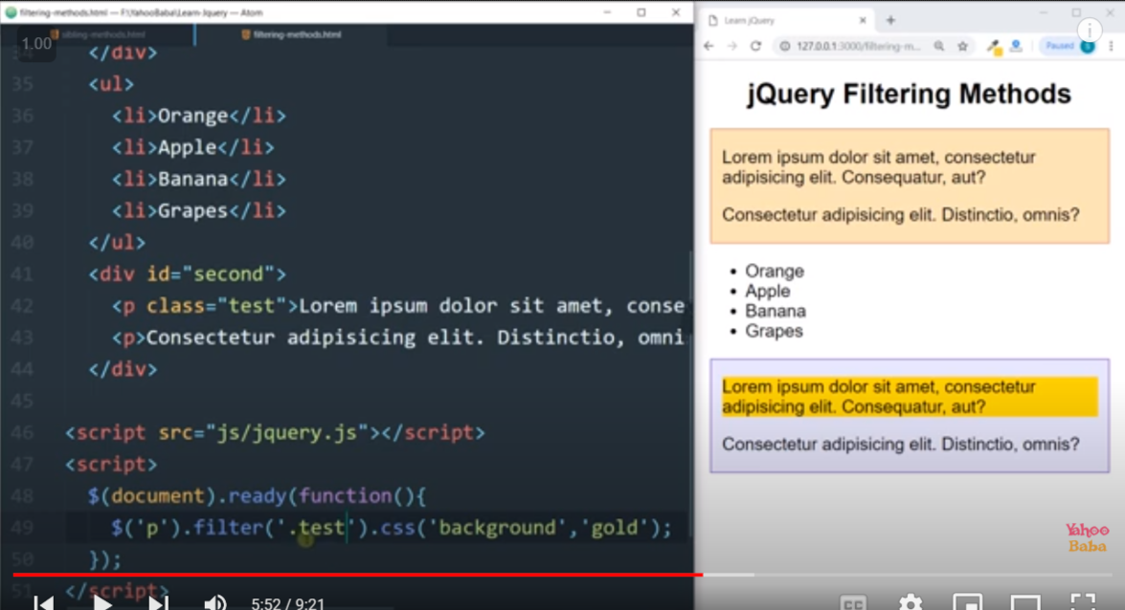

Not() eg :

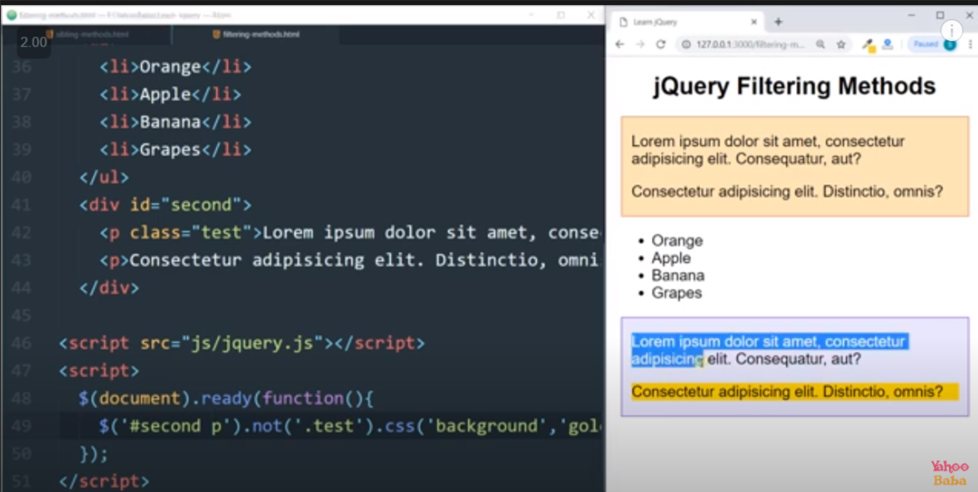

Slice() : eg

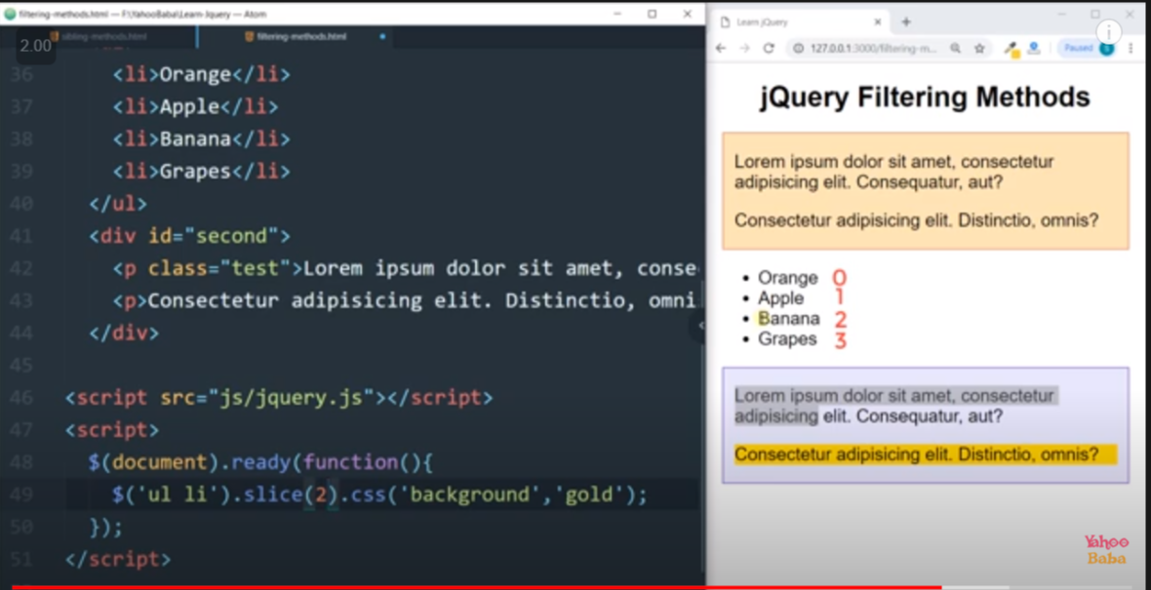

15.

1)has() :

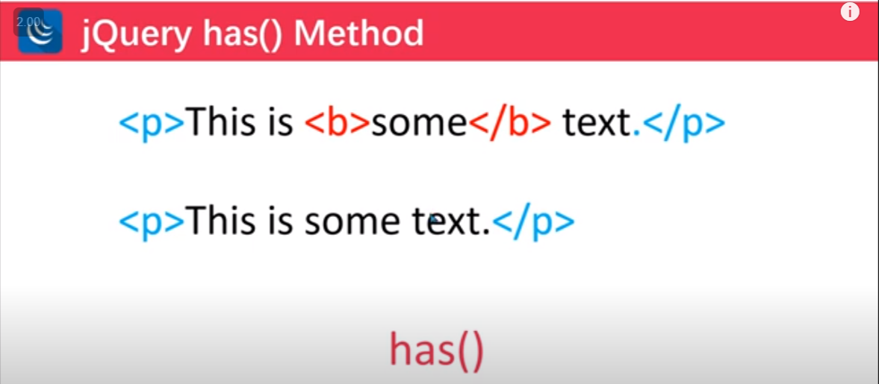

Eg :

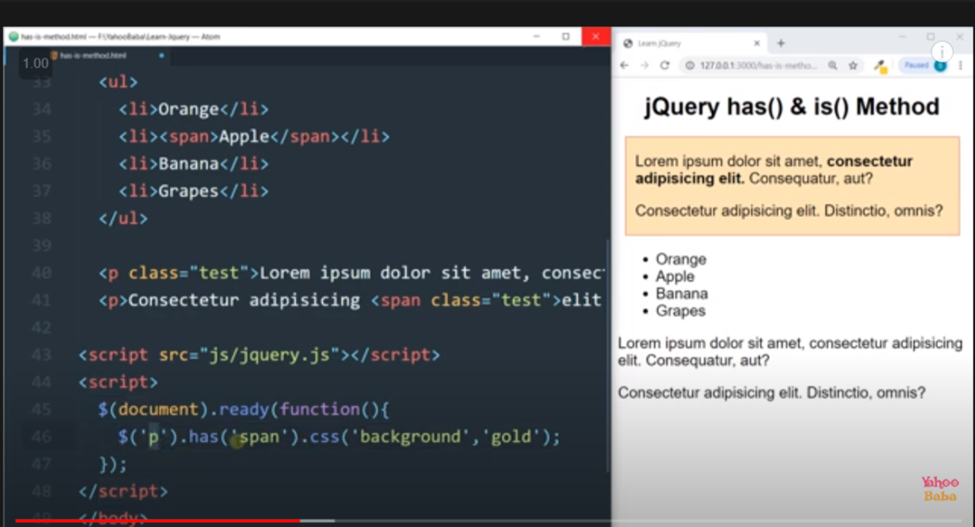

Has with the multiple argument :

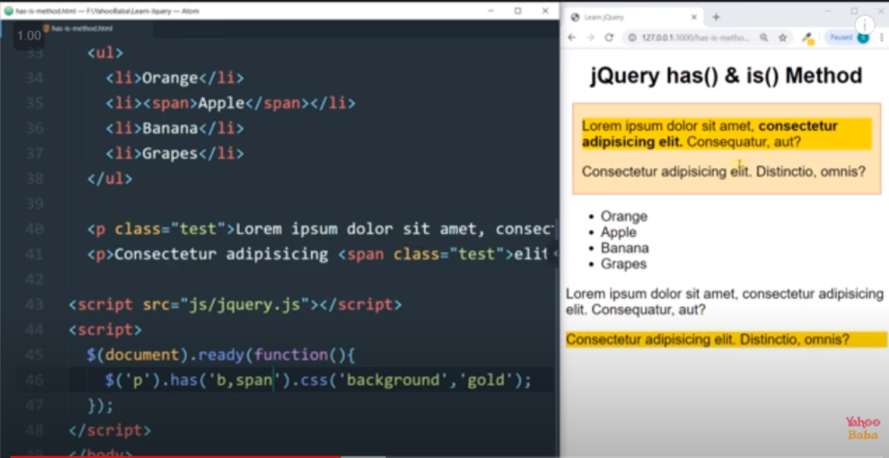

Note : in has we can also pass class or id

2) is() :

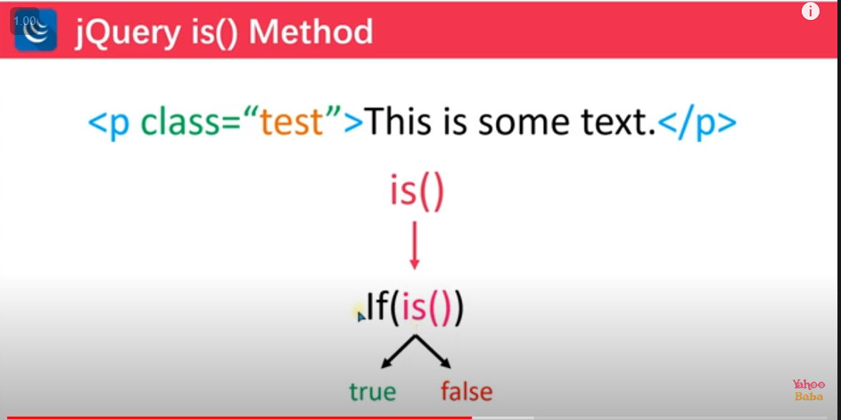

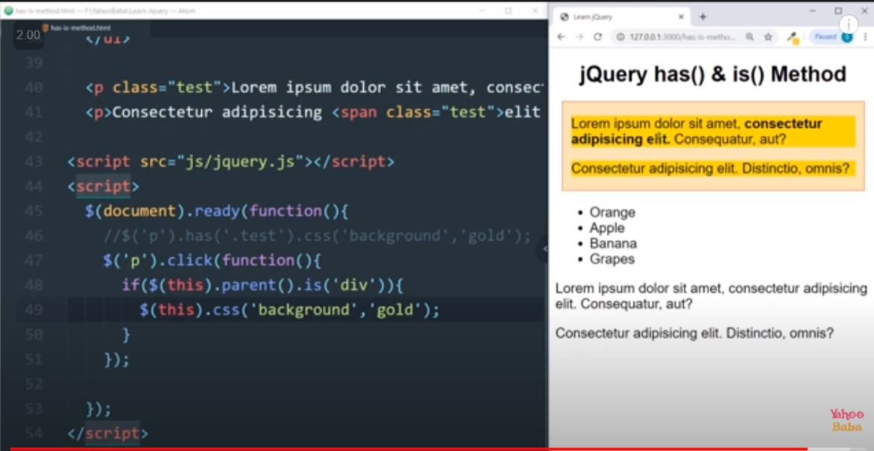

15.3)Each()

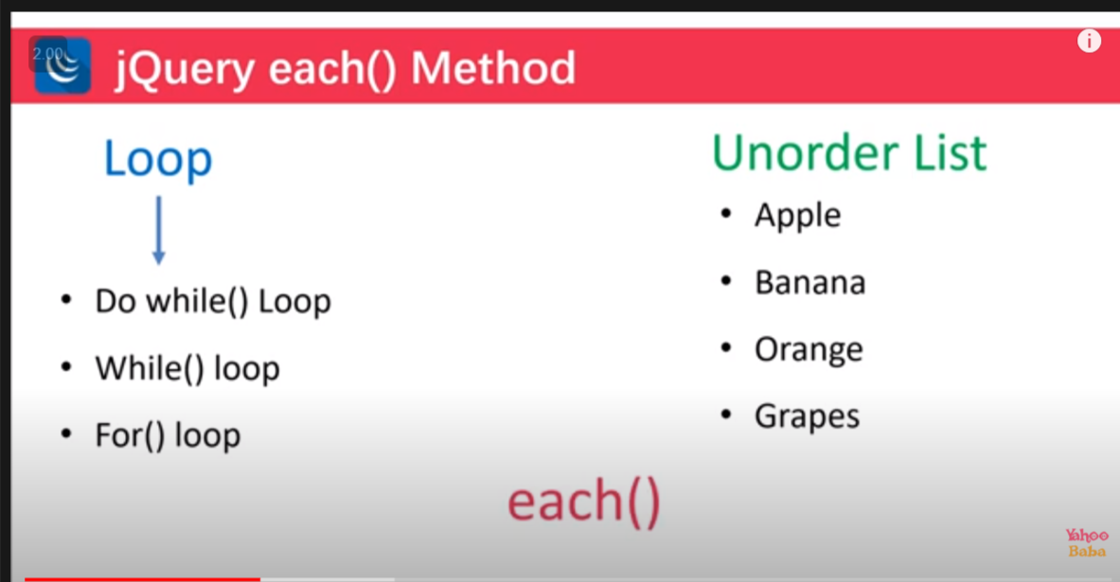

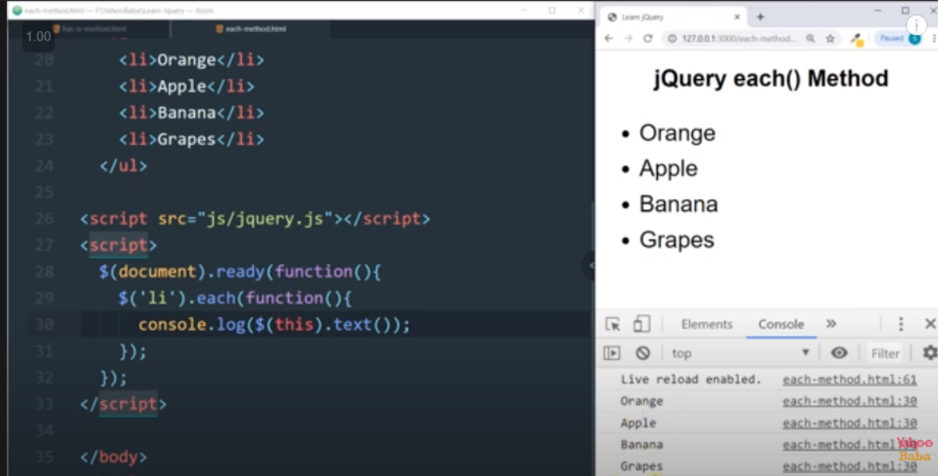

16. Event :

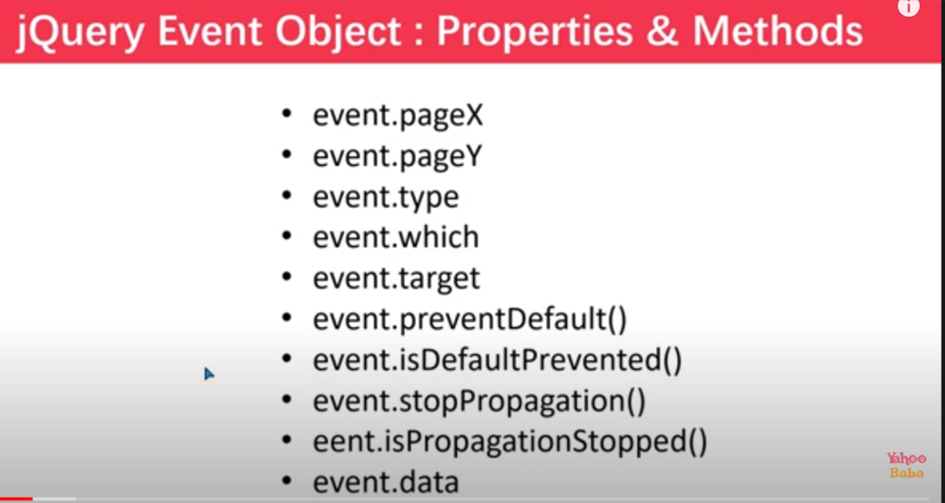

1.event.pagex/.pagey

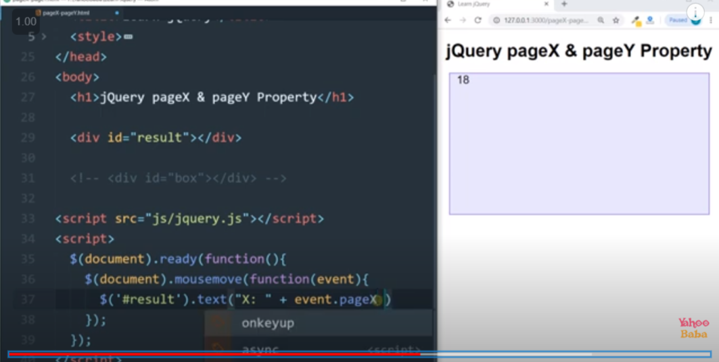

2.event.type

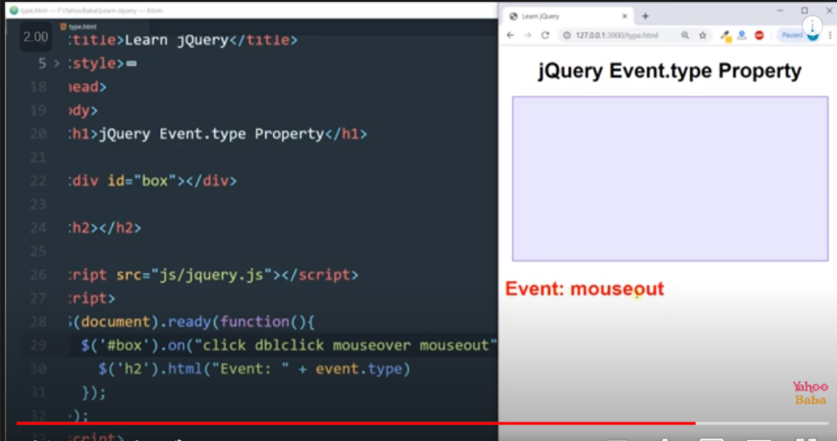

3.Event Which

1.for mouse for left click event.which=1 , for right click event.which=2 ,for center click event.which=3

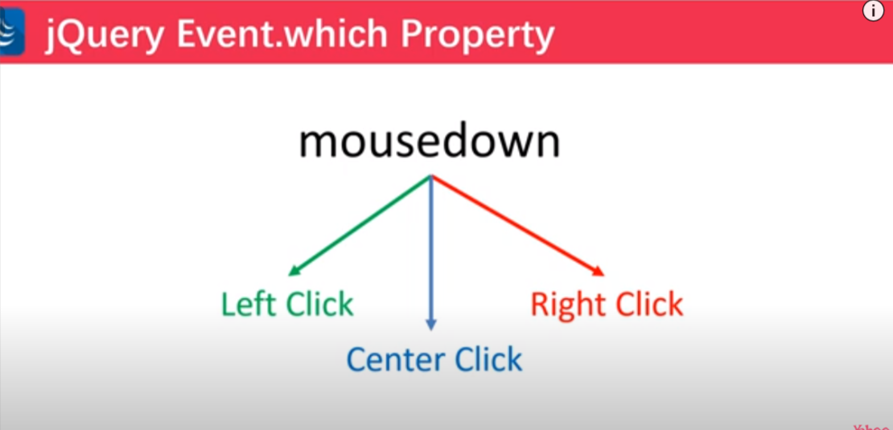

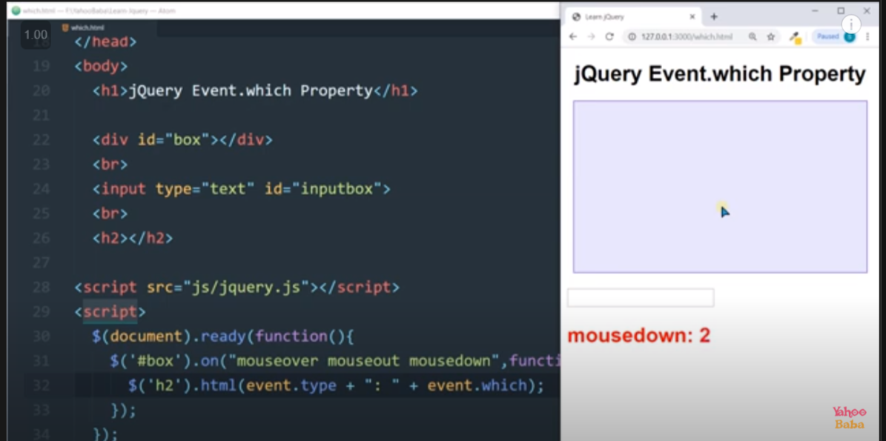

2.keypress event : it give value in form of ASSICS VALUE

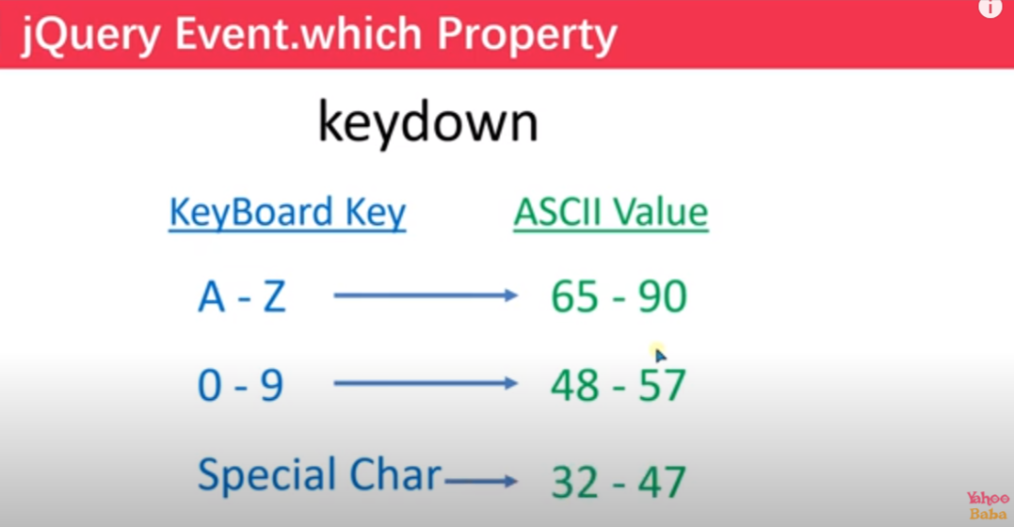

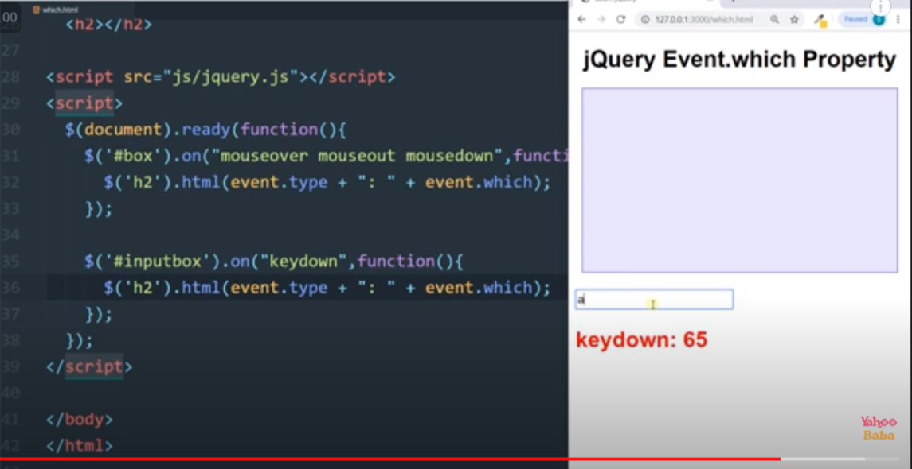

4.event.target :

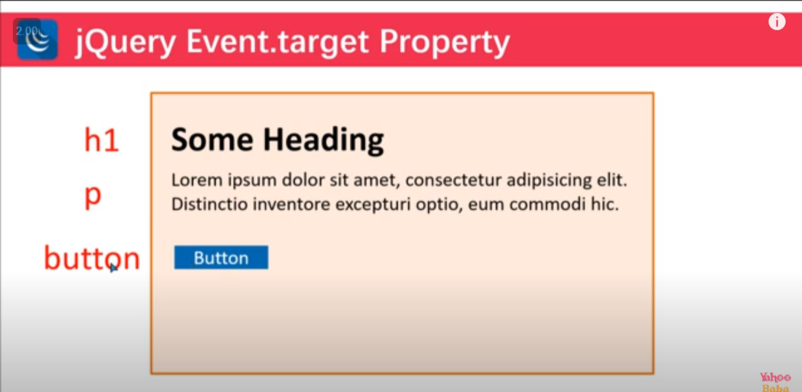

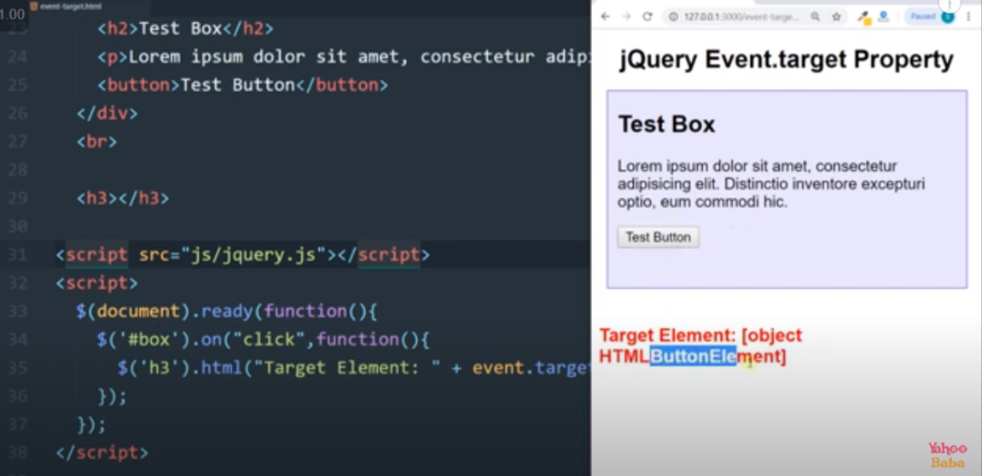

To get exact target use : event.target.NodeName

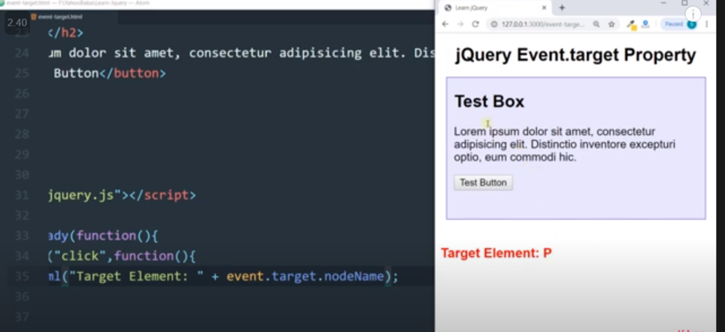

5.event.preventdefault():

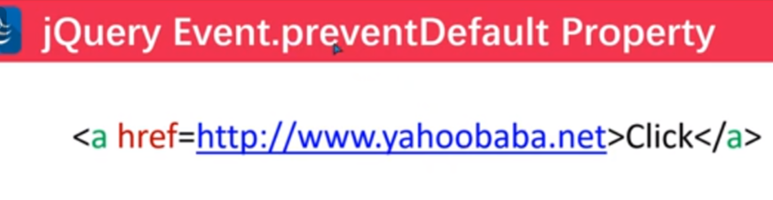

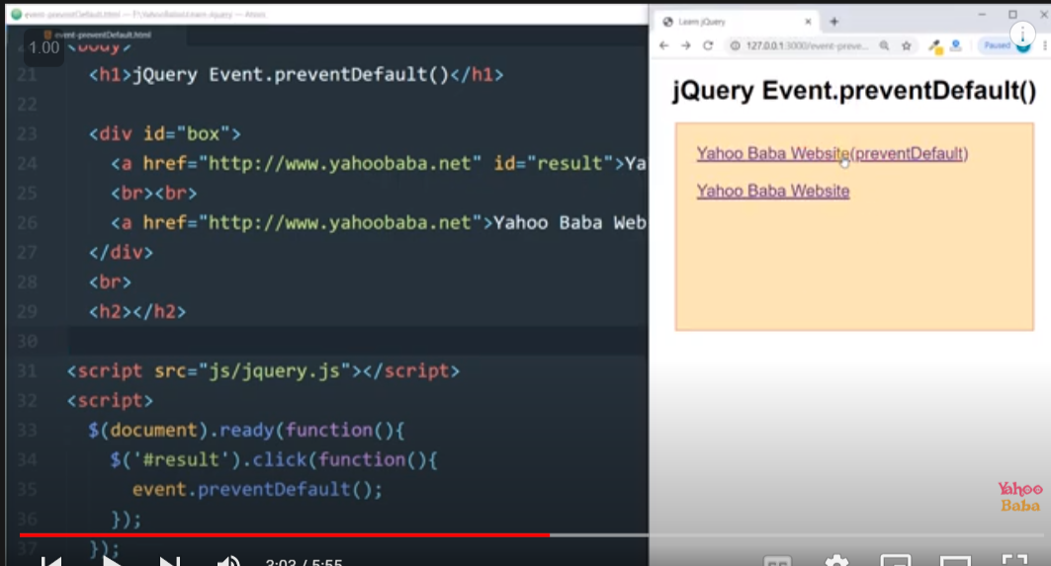

5.2.event.isDefaultPrevented():

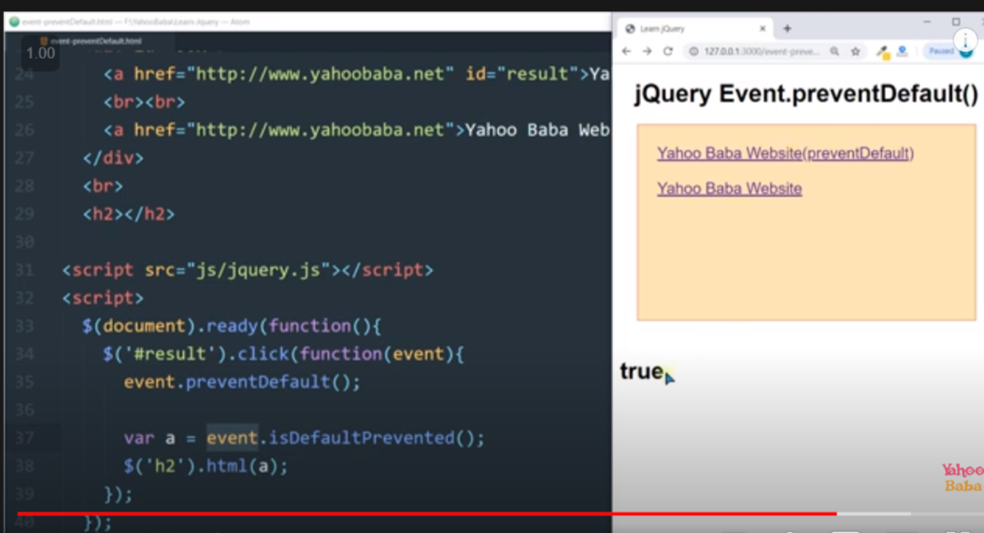

6. event.stopProgation() : it is used to stop event bubbling .

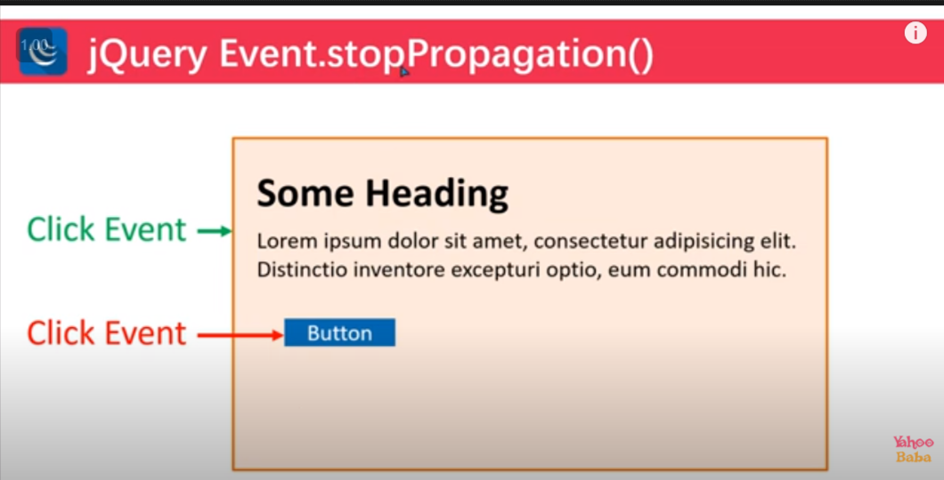

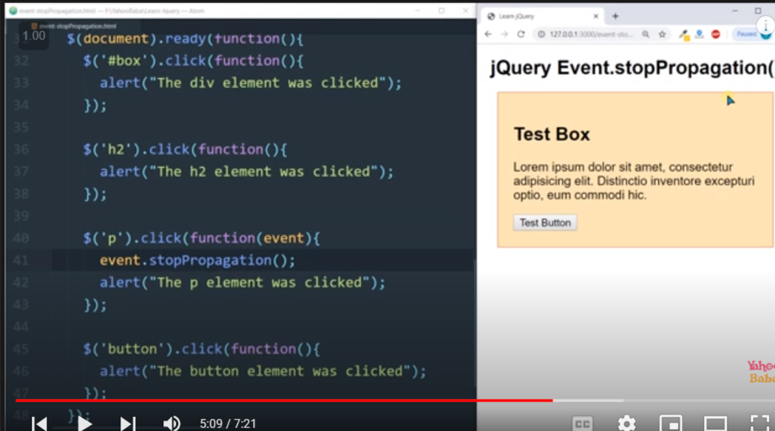

6.2 event.ispropgationStoped() : give true or flase based on use of event.stopPropgation()

7.event.data

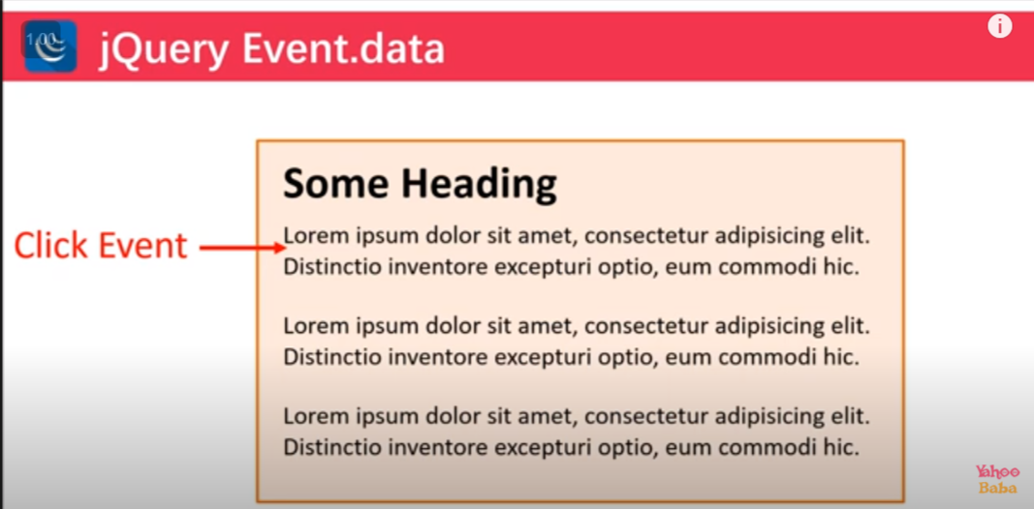

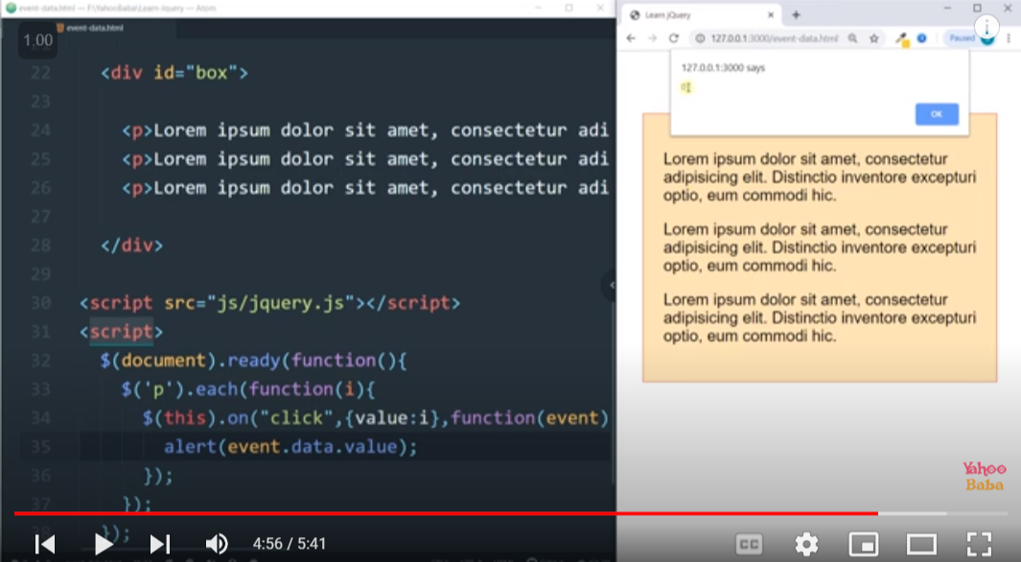

17. j query plugins :

Website for j query and JavaScript plugins : Best jQuery

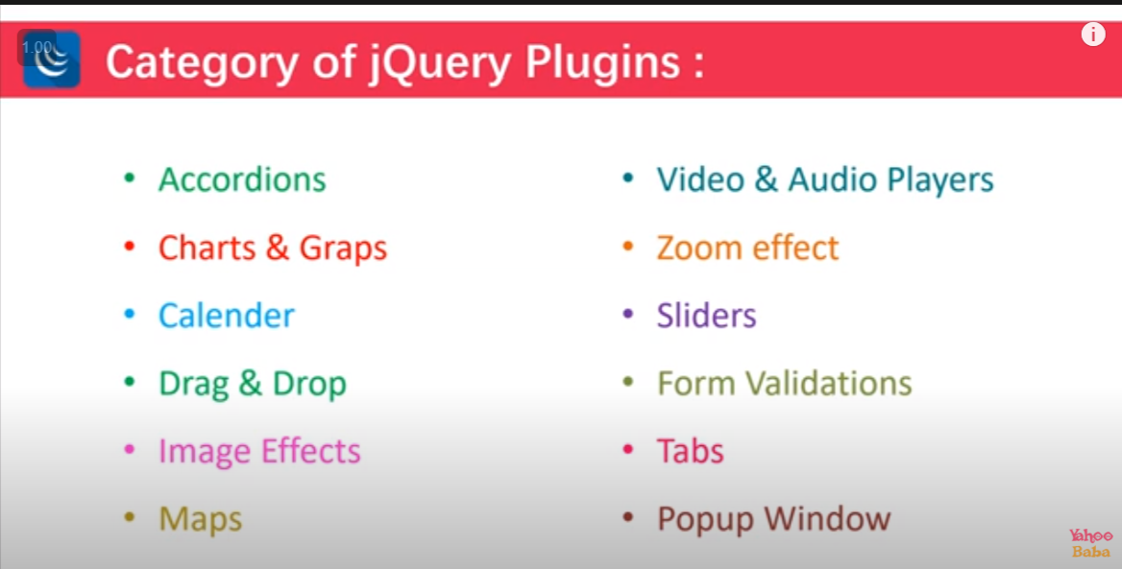

Way to add plugins :

